BAOSI BANIKANTA KAKATI COLLEGE
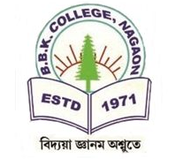
Nagaon, Barpeta
Dr. Manalisha Deka
HoD

Assam-781311 (INDIA)
Department of Zoology

Report on
Celebration of Students Day, 2025
Date: 4th April, 2025
Department of Zoology
Venue ZL-2
BBK College, Nagaon, Barpeta

The Department of Zoology at BBK College celebrated Students' Day in honor of the birthday of Bodofa Upendra Nath Brahma, a distinguished Bodo leader, social activist, and visionary. This special day, observed on March 31st, serves as a tribute to his remarkable contributions and importance of education in shaping society. The celebration commenced with an insightful and thought-provoking speech by Ms. Illora Narzery, Assistant Professor in the Department of Zoology. She provided an in-depth account of the life history and enduring legacy of Bodofa Upendra Nath Brahma, emphasizing his pivotal role in advocating for education and his significant impact on the Bodo community. The Principal of BBK College, Dr. Pradip Das delivered an informative lecture and elaborated the life and work of Bodofa U.N. Brahma, emphasizing his vision for a better, more educated society. His words were both inspiring and motivating, encouraging students to embrace the values of education, leadership, and social responsibility that Brahma championed. The event concluded with a heartfelt vote of thanks, acknowledging the contributions of all those who made the event successful.



Dr. Manalisha Deka, HoD
Department of Zoology
BBK College, Nagaon, Barpeta

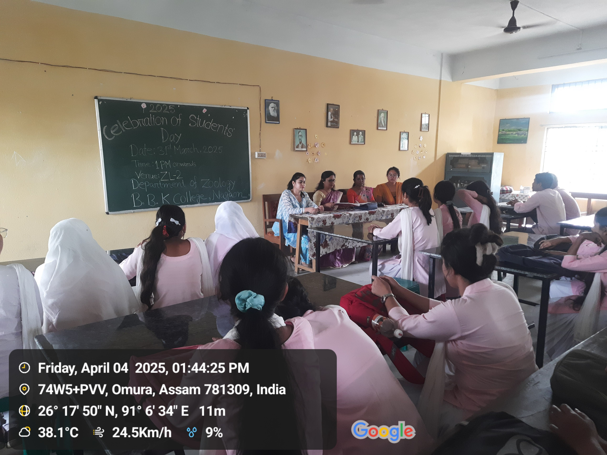
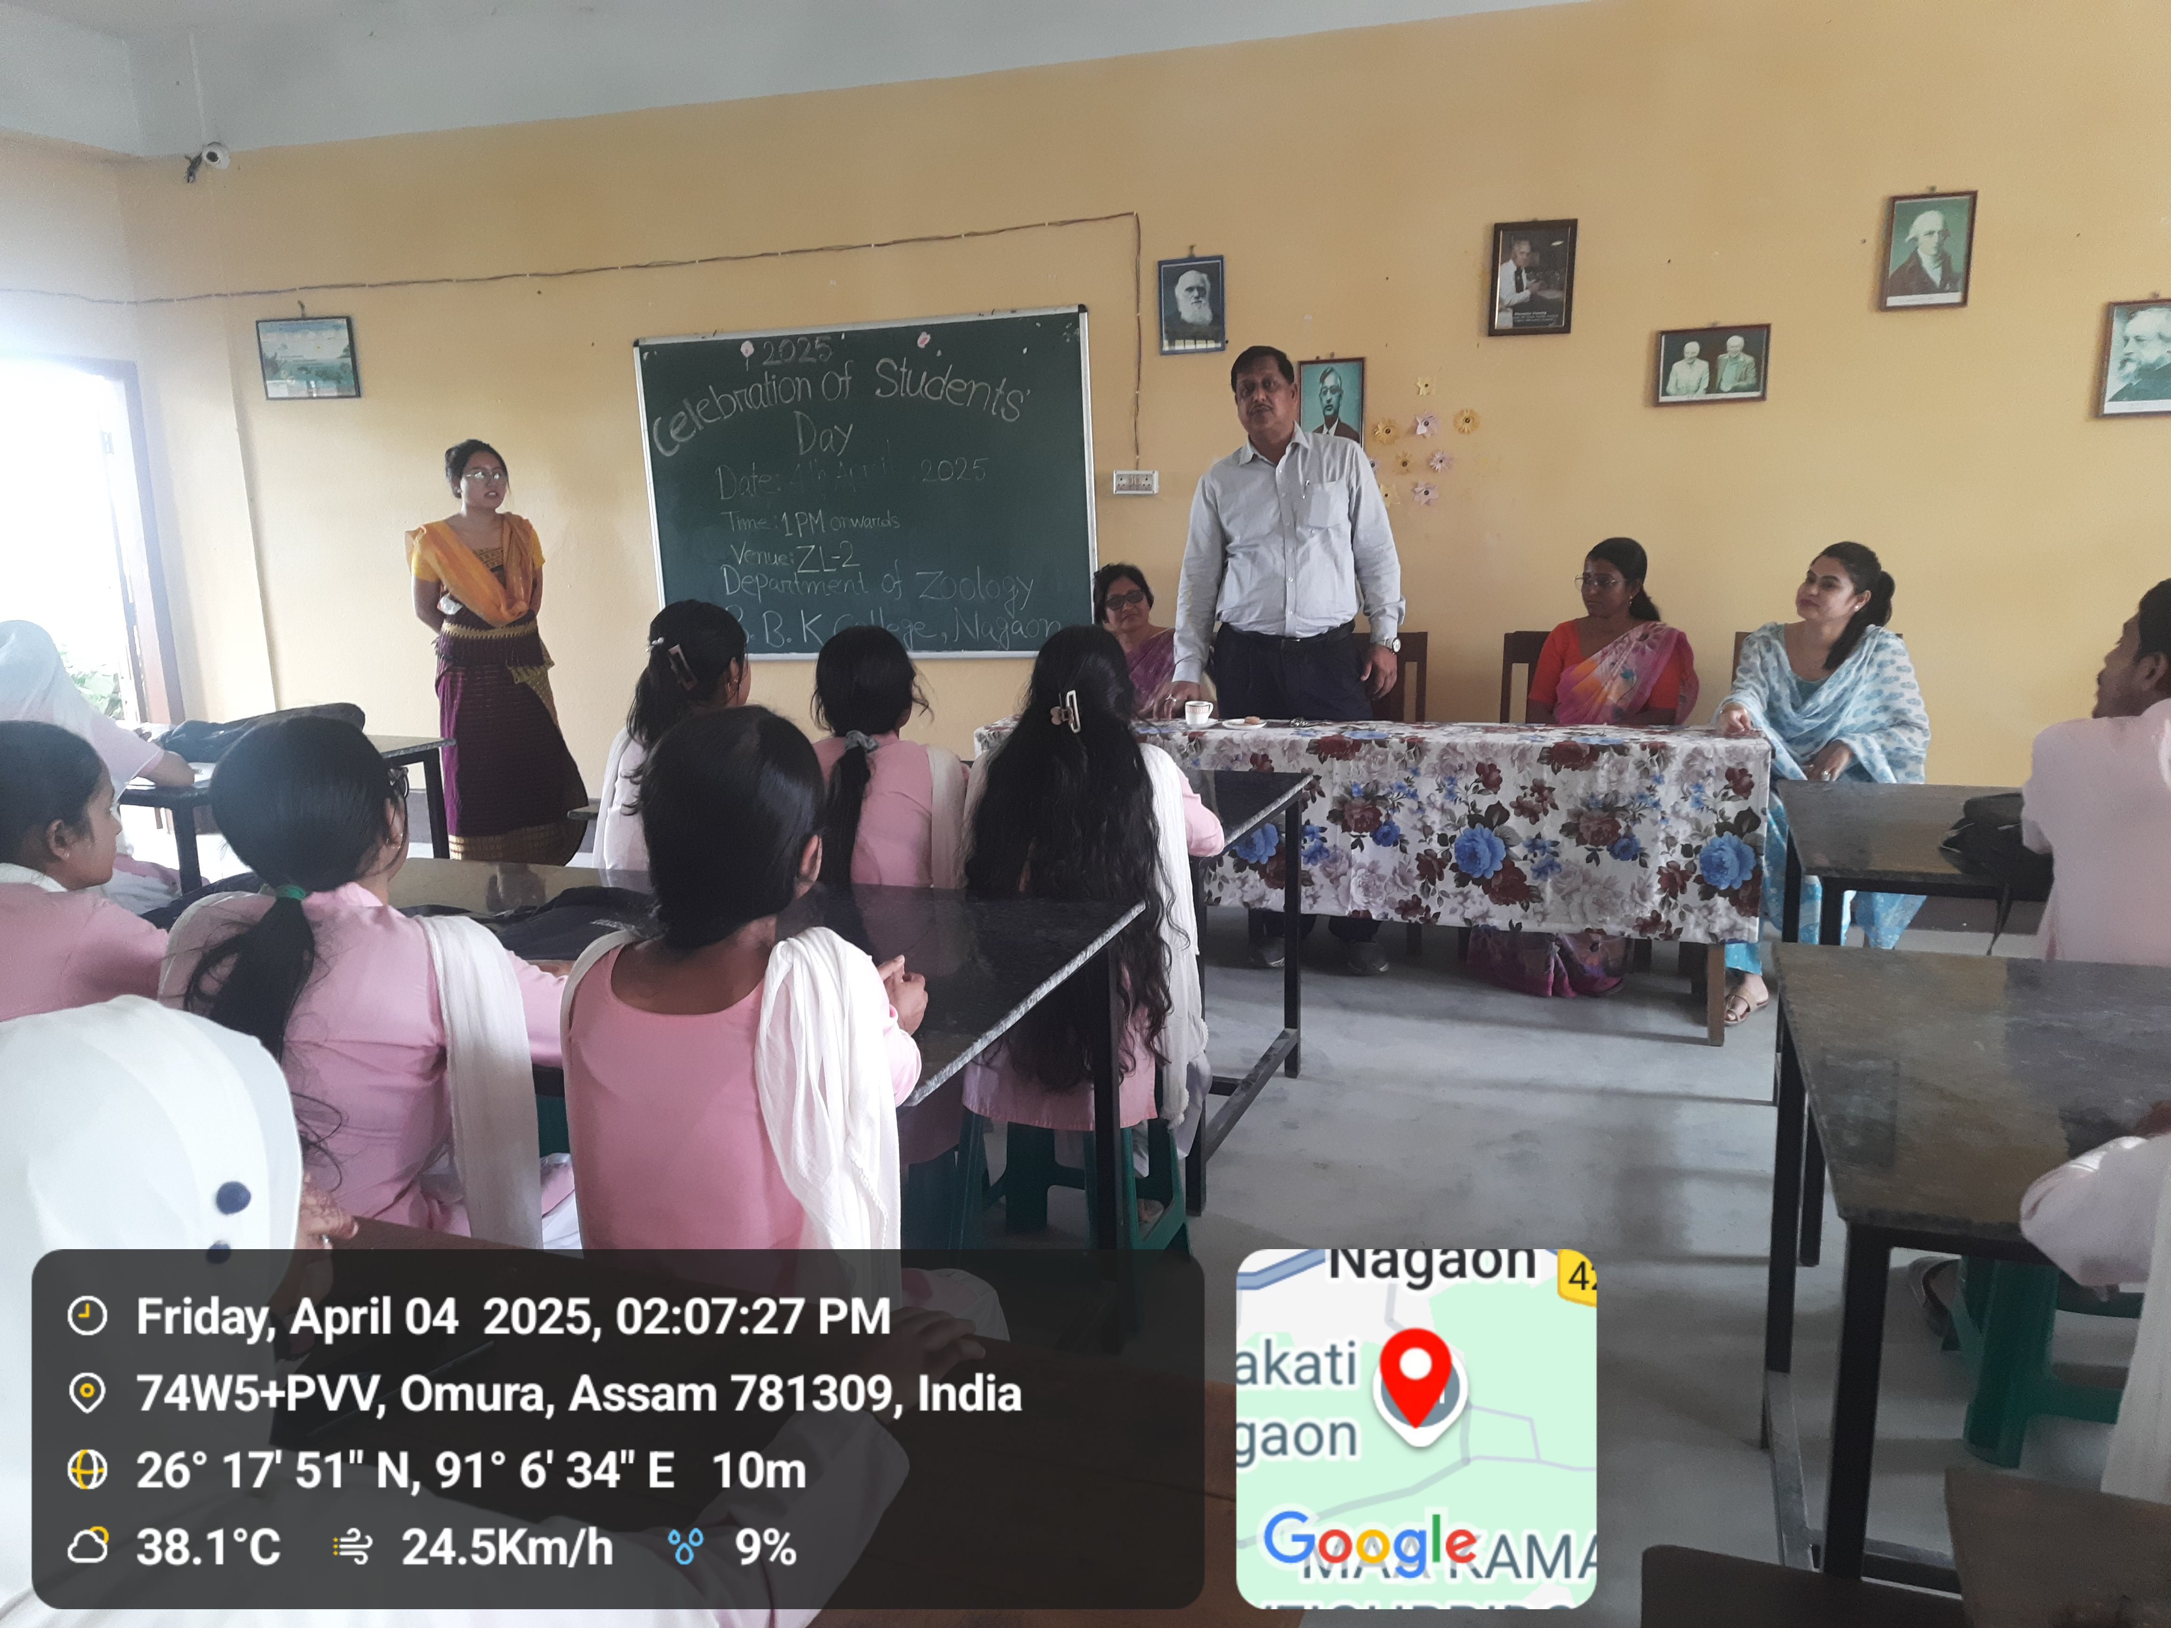

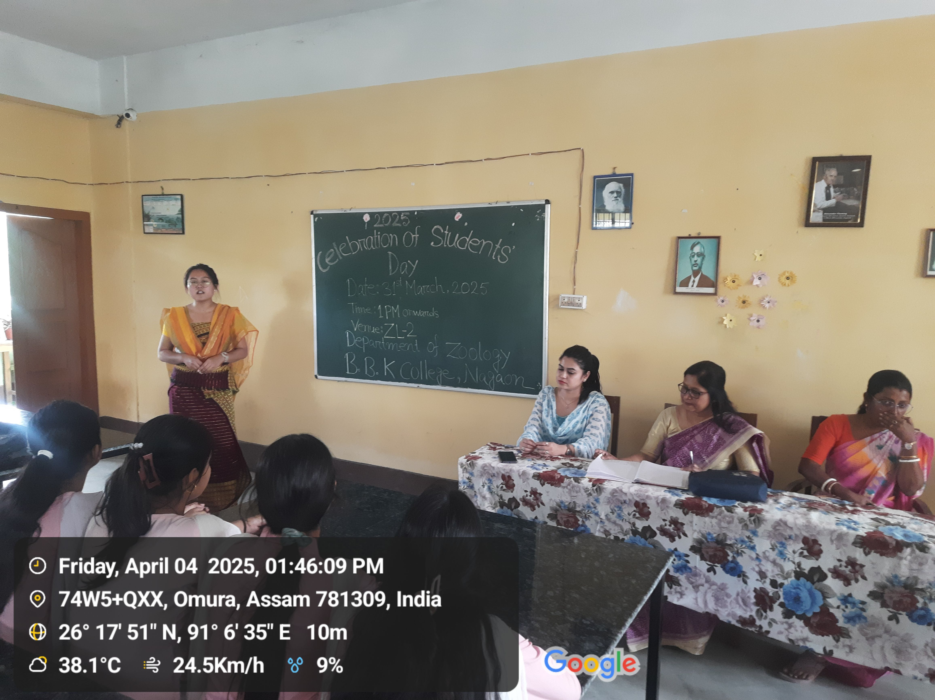
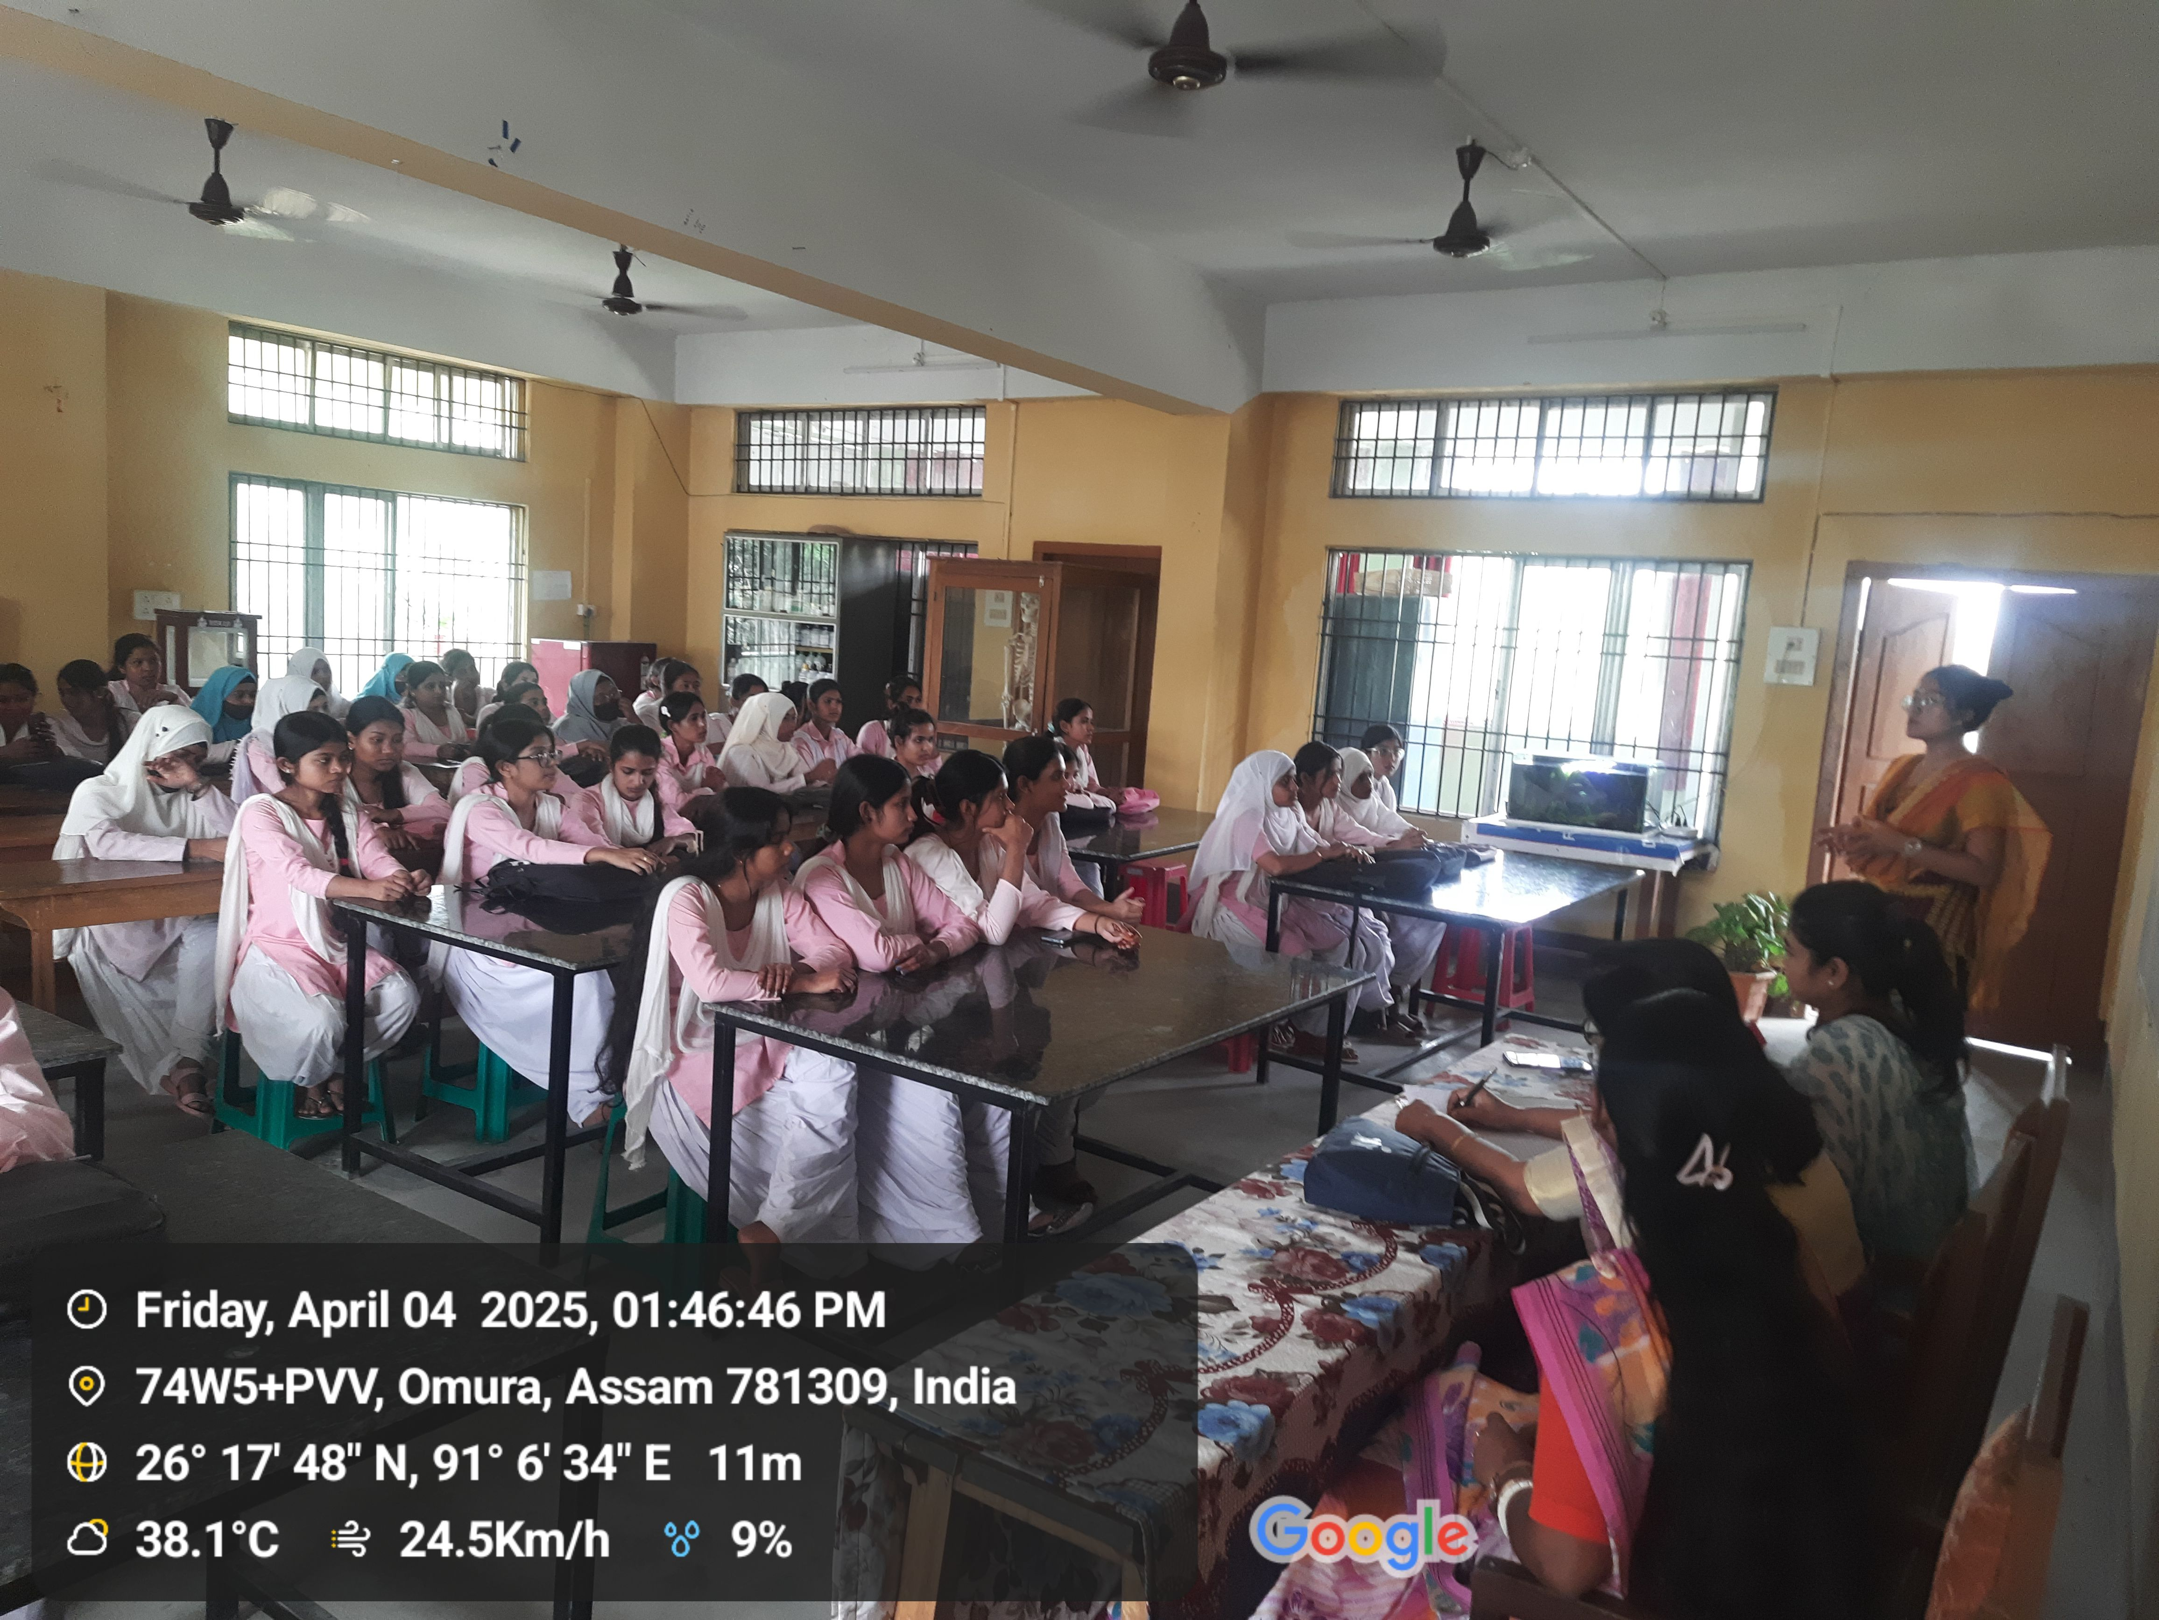

Dr. Manalisha Deka, HoD
Department of Zoology
BBK College, Nagaon, Barpeta

