BAOSI BANIKANTA KAKATI COLLEGE
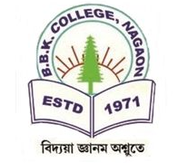
Nagaon, Barpeta
Dr. Manalisha Deka
HoD

Assam-781311 (INDIA)
Department of Zoology

Report on
Interactive Session, 2025
Date: March 7, 2025
BBK College, Nagaon, Barpeta
Department of Zoology

An interactive session was held on 7th March 2025, where alumni from the Zoology Department, Azam Ali, a student of the 2021-2024 batch, engaged with B.Sc. 6th semester students. The event was designed to provide students with an opportunity to learn from the experiences and insights of the alumni. Azam Ali, currently preparing for various competitive exams such as Civil Services, Bank PO, SSC, among others, shared his journey and offered valuable guidance. The session successfully facilitated academic and professional discussions, providing students with career advice and networking opportunities. The interactive session was a resounding success, offering participants crucial insights into their future endeavors.

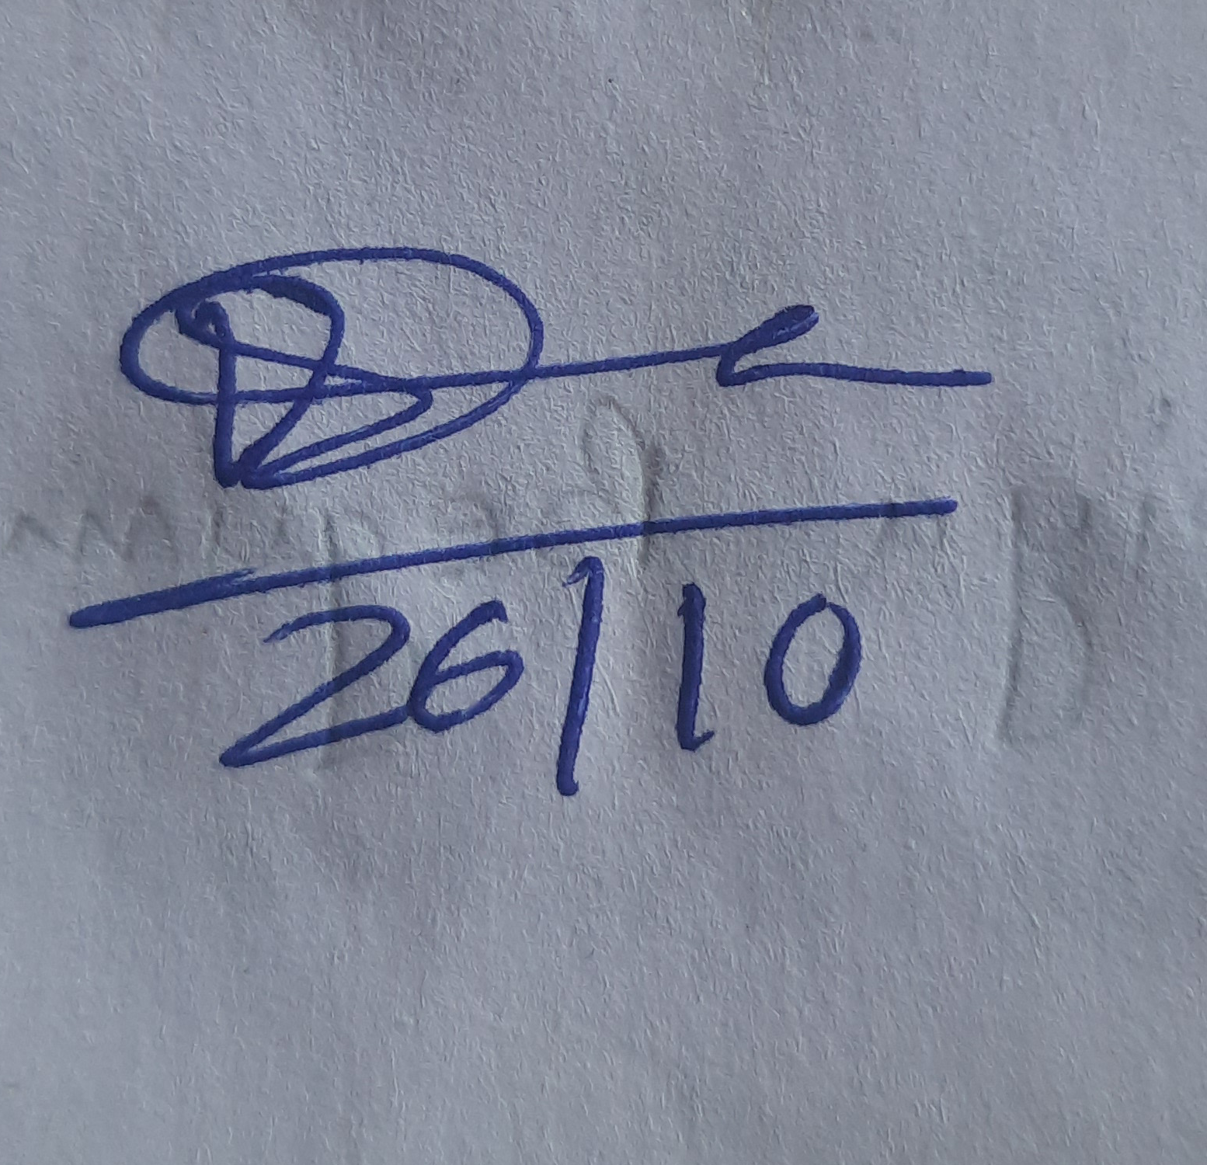

Dr. Manalisha Deka, HoD
Department of Zoology
BBK College, Nagaon, Barpeta

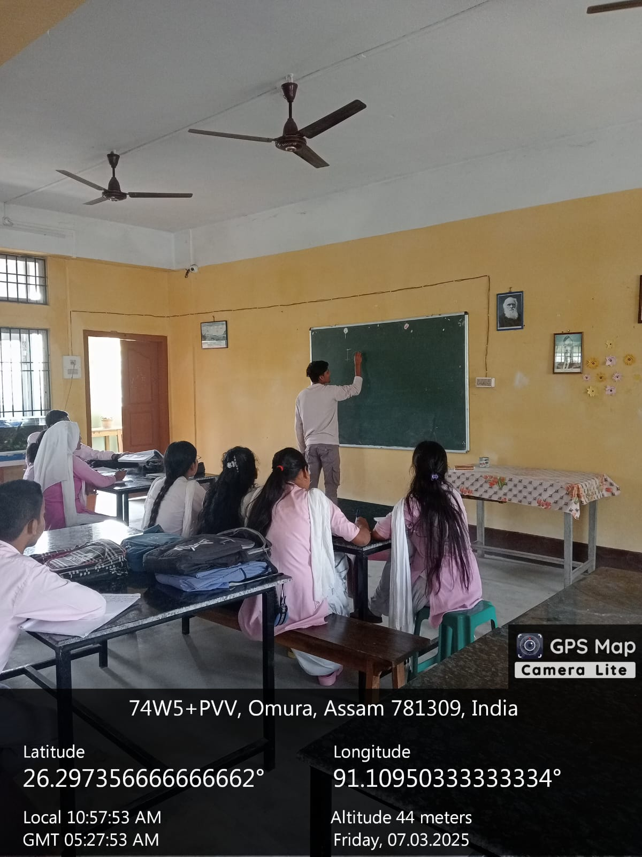
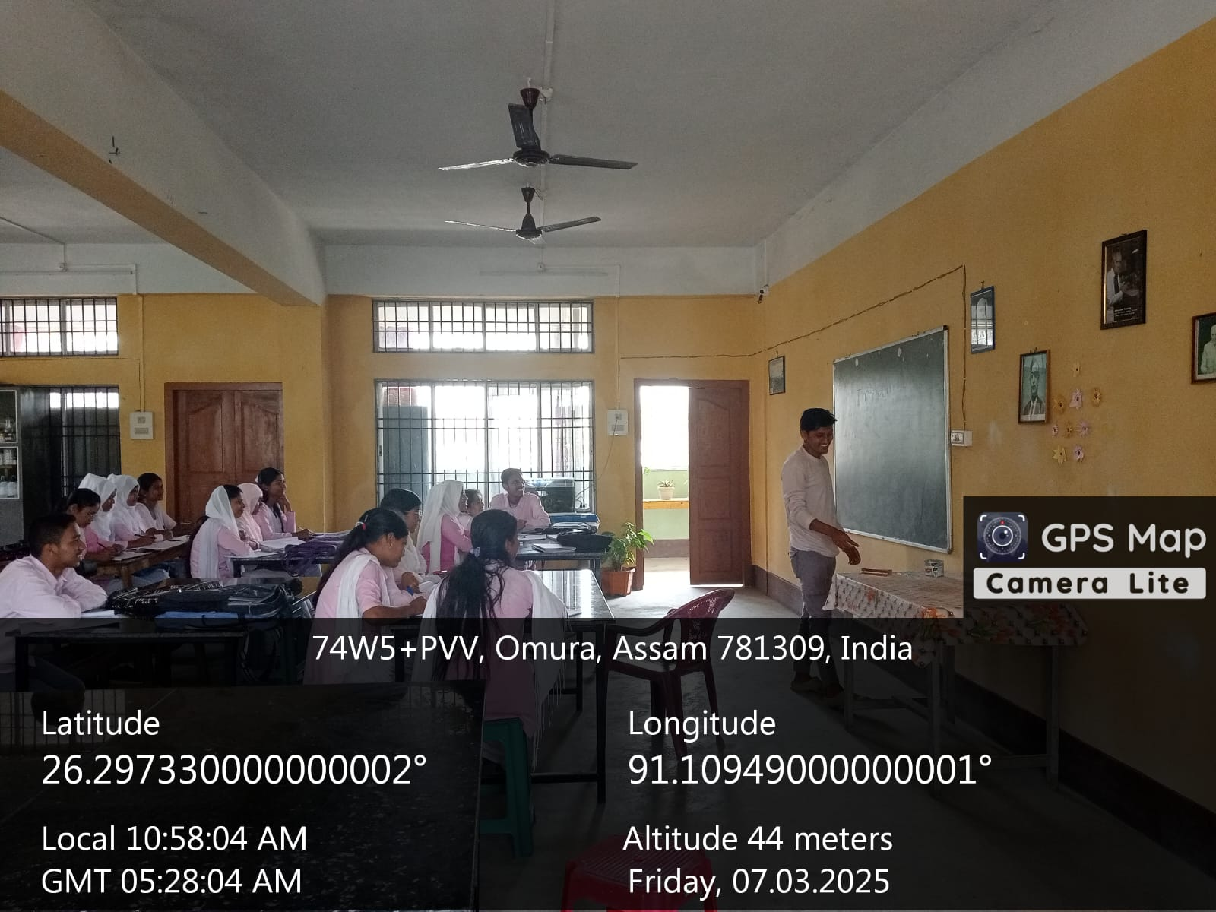

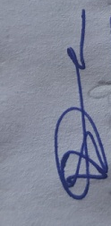
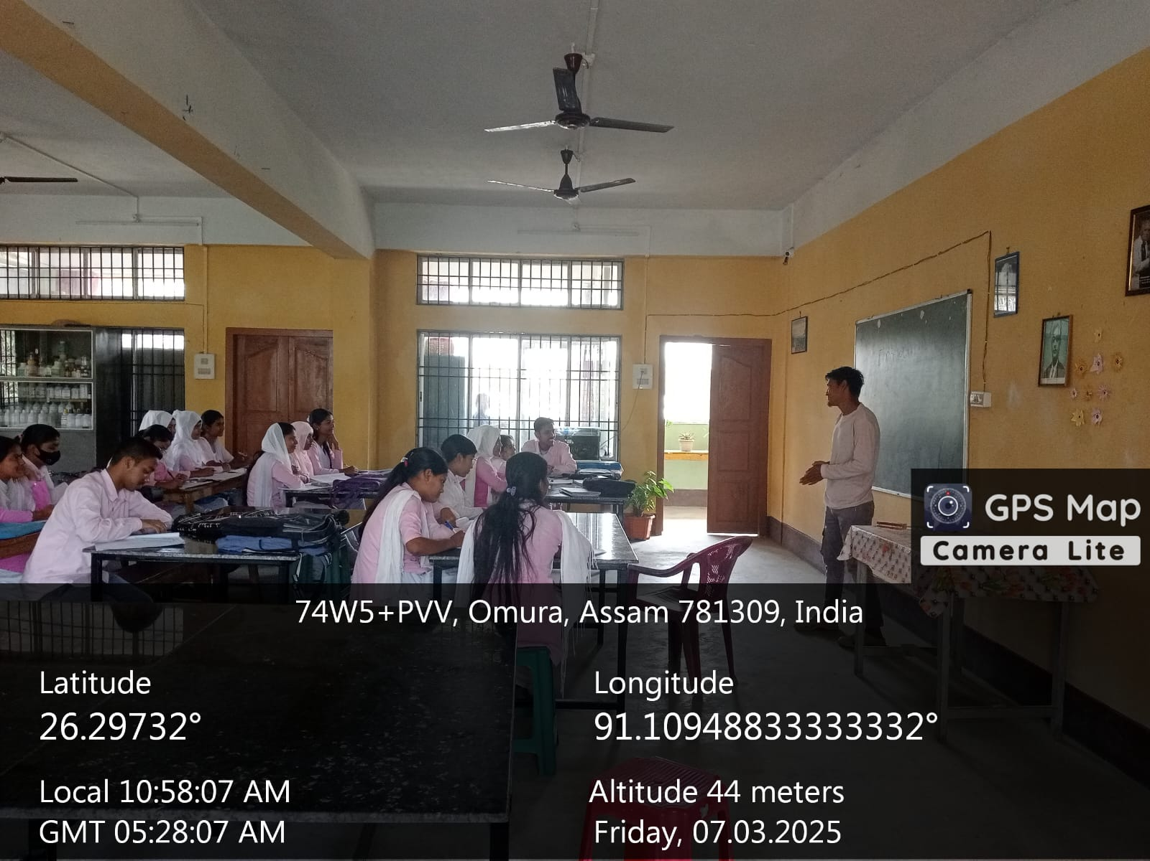
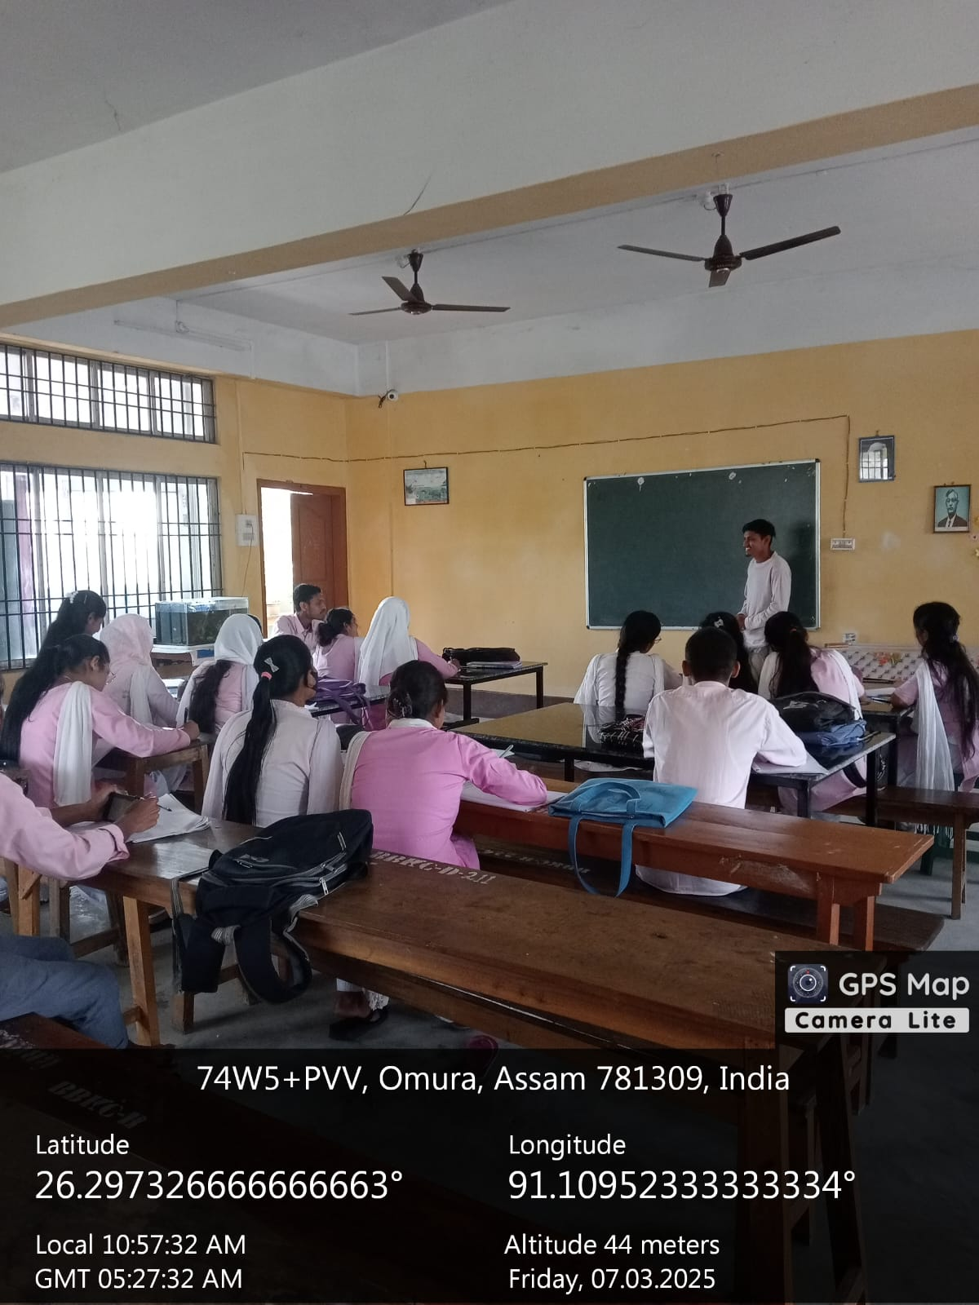

Dr. Manalisha Deka, HoD
Department of Zoology
BBK College, Nagaon, Barpeta

