BAOSI BANIKANTA KAKATI COLLEGE

Nagaon, Barpeta
Dr. Manalisha Deka
HoD

Assam-781311 (INDIA)
Department of Zoology

Report on
Inauguration of Departmental Magazine, 2025
Date: 28 February, 2025
Venue: RUSA, BBK College
Organized by: Department of Zoology
BBK College, Nagaon, Barpeta
Department of Zoology

National Science Day (NSD) was celebrated at BBK College on February 28th, 2025, organized by the Science Forum. This annual event, which was formerly organized by the Department of Zoology, has been taken over by the newly formed Science Forum, which now oversees its observance. The event began with the formal inauguration of the departmental wall magazine “Skype” at 10:30 AM. The respected Principal of BBK College, graced the occasion and delivered an insightful speech on the significance of the wall magazine. The magazine serves as a platform for students to express their scientific thoughts and ideas, contributing to academic atmosphere at the college. The official meeting commenced at 11:00 AM and was chaired by the Principal of BBK College. During the meeting, the fifth volume of the departmental magazine “Zoologica,” published by the Department of Zoology, was formally inaugurated. The magazine showcases the research work, students article and activities of the department and serves as a valuable resource for students and faculty alike.



Dr. Manalisha Deka, HoD
Department of Zoology
BBK College, Nagaon, Barpeta

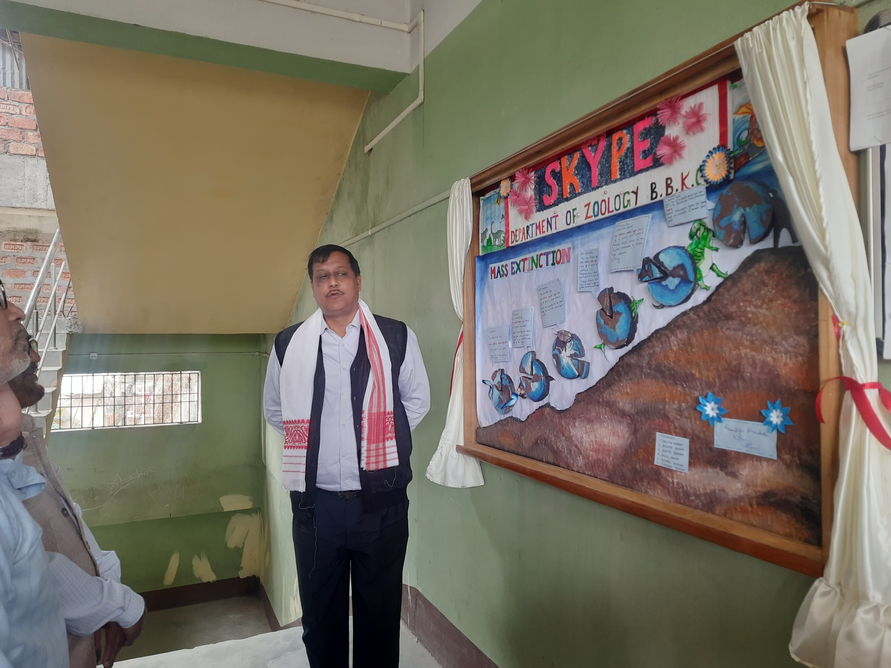
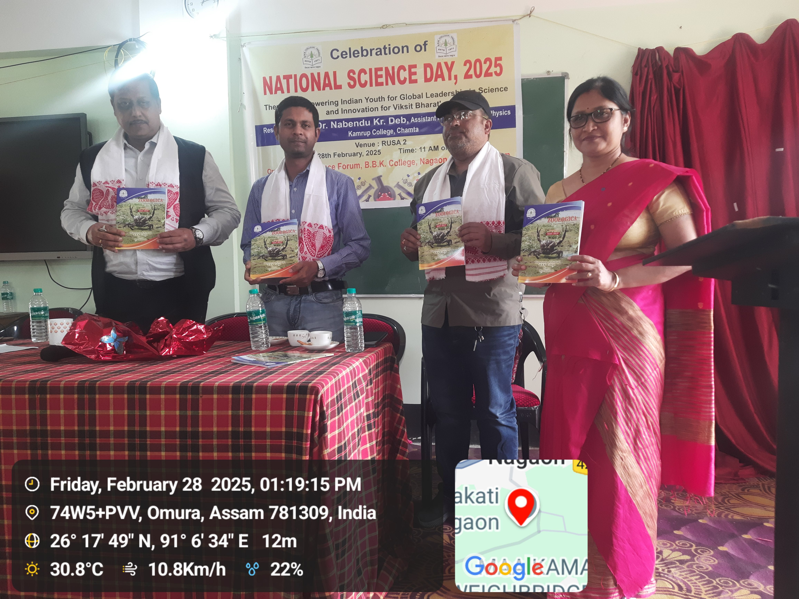

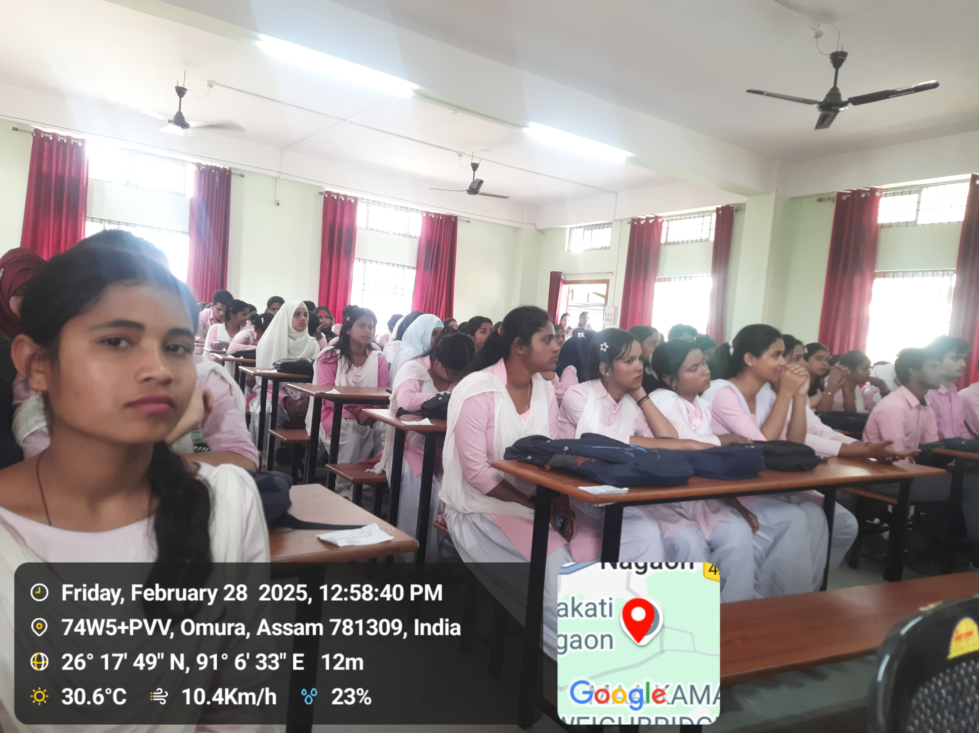
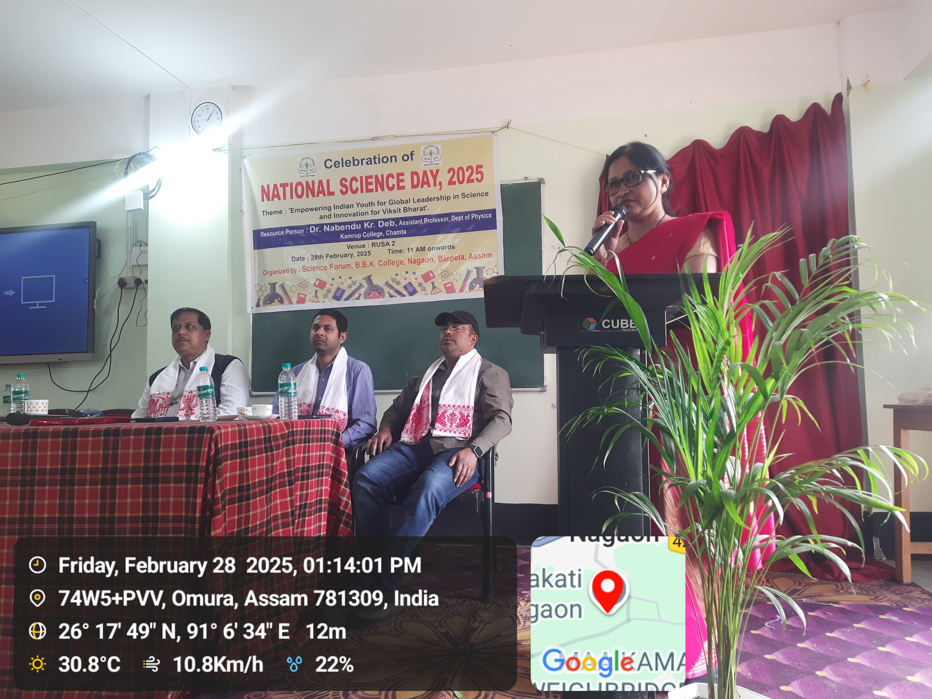

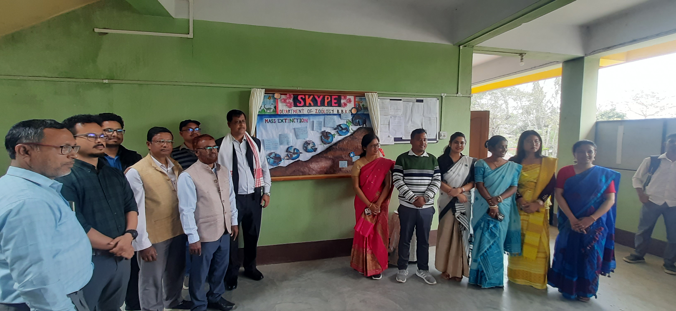

Dr. Manalisha Deka, HoD
Department of Zoology
BBK College, Nagaon, Barpeta

