BAOSI BANIKANTA KAKATI COLLEGE
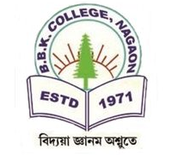
Nagaon, Barpeta
Dr. Manalisha Deka
HoD

Assam-781311 (INDIA)
Department of Zoology

Report on
Inauguration of Nijut Moina Asoni, 2024
Date: August 8, 2024
Venue: New Hall, BBK College
BBK College, Nagaon, Barpeta
Guest: D.C. Barpeta, Mr. Ashraful Hussain, MLA Chenga constituency
Organizer: Govt. of Assam

On 8th August, 2024, BBK College witnessed the grand Inauguratiin of Nijut Moina asoni, a significant installation that mark a new chapter in the college commitment to upliftment. The event took place at the B. B. K. College campus. The inauguration ceremony began at 11.00 A.M with warm welcome address by the Principal, BBK College. The Principal, BBK College expressed the importance of “ Nijut Moina Asoni ”, which enrich and benefits for the education of girls students. Total no. of 25 faculty member and 130 students present in the event. The Guest for the occasion Deputy Commissioner, Barpeta Dist and Mr. Ashraful Hussain, MLA Chenga addressed the audience highlighting the scheme Nijut Moina. The certificates were distributed by the Principal, BBK College, DC Barpeta, MLA Chenga, Mr. Ashraful Hussain. A total of 368 student beneficiaries of Nijut Moina Asoni were included in this scheme at BBK college. The event concluded expressing the gratitude to the guest, students and faculty members.



Dr. Manalisha Deka, HoD
Department of Zoology
BBK College, Nagaon, Barpeta

Photographs of Inauguration program of Nijut Moina Asoni :
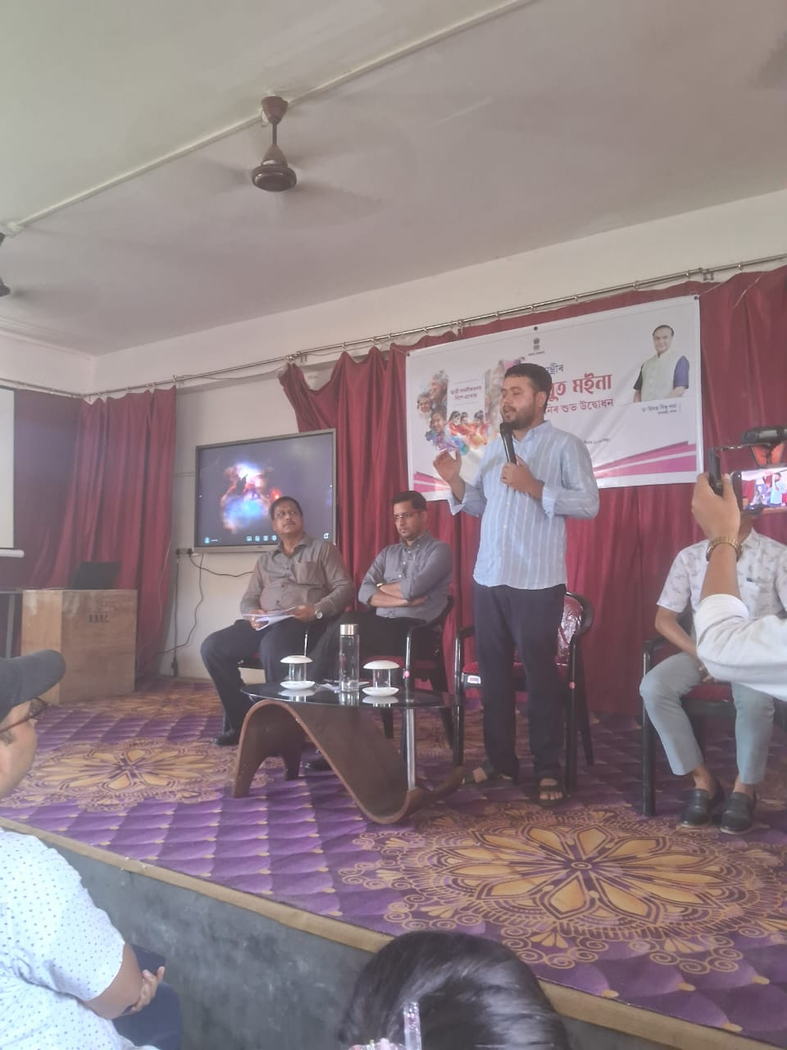
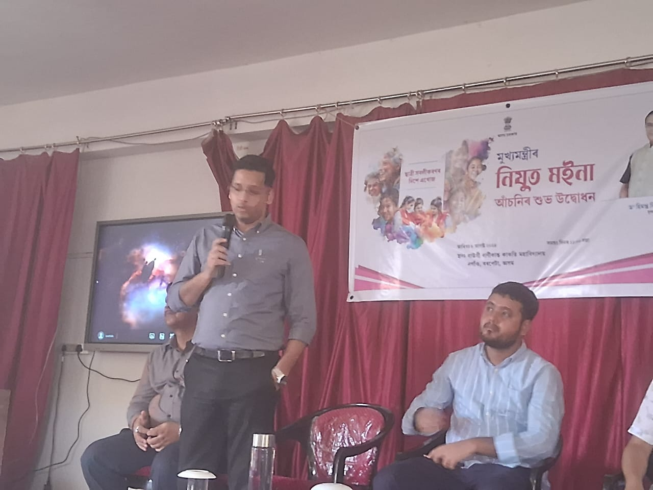

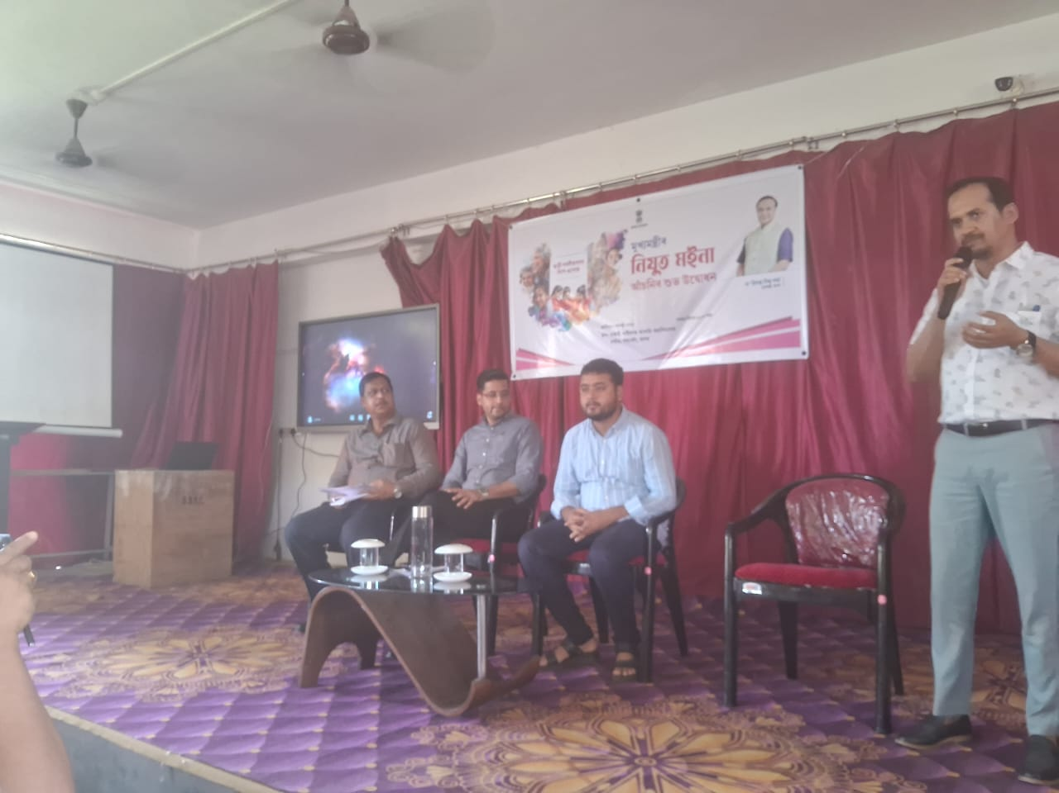

Dr. Manalisha Deka, HoD
Department of Zoology
BBK College, Nagaon, Barpeta

