BAOSI BANIKANTA KAKATI COLLEGE
Dr. Manalisha Deka
HoD

Nagaon, Barpeta
Assam-781311 (INDIA)
Department of Zoology
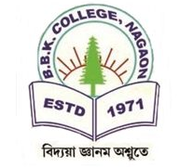
Report on
10th International Humanity Olimpiad
Date: 20th August -30th August, 2024, BBK College
Location: BBK College, Nagaon, Barpeta
Organizer: Gov. of Assam
Name of the website: www.humanityolympaid.org

The 10th International Humanity Olympiad (IHO) 2024 was successfully held from August 20th to August 30th at BBK College. The event commenced with an inspiring keynote address delivered by the Principal of BBK College. The International Humanity Olympiad is a prestigious examination that tests participants on their understanding of human rights, global issues, ethical decision-making, and leadership skills, fostering excellence in the realms of humanity, morality, and ethics. This year, the competition saw the enthusiastic participation of 150 students, each eager to showcase their knowledge and skills. Out of the total participants, 4 outstanding students emerged victorious, qualifying for the next stage and receiving well-deserved certificates for their exceptional performance. The event was a significant success, highlighting the commitment to promoting human values and ethical leadership among the younger generation.



Dr. Manalisha Deka, HoD
Department of Zoology
BBK College, Nagaon, Barpeta

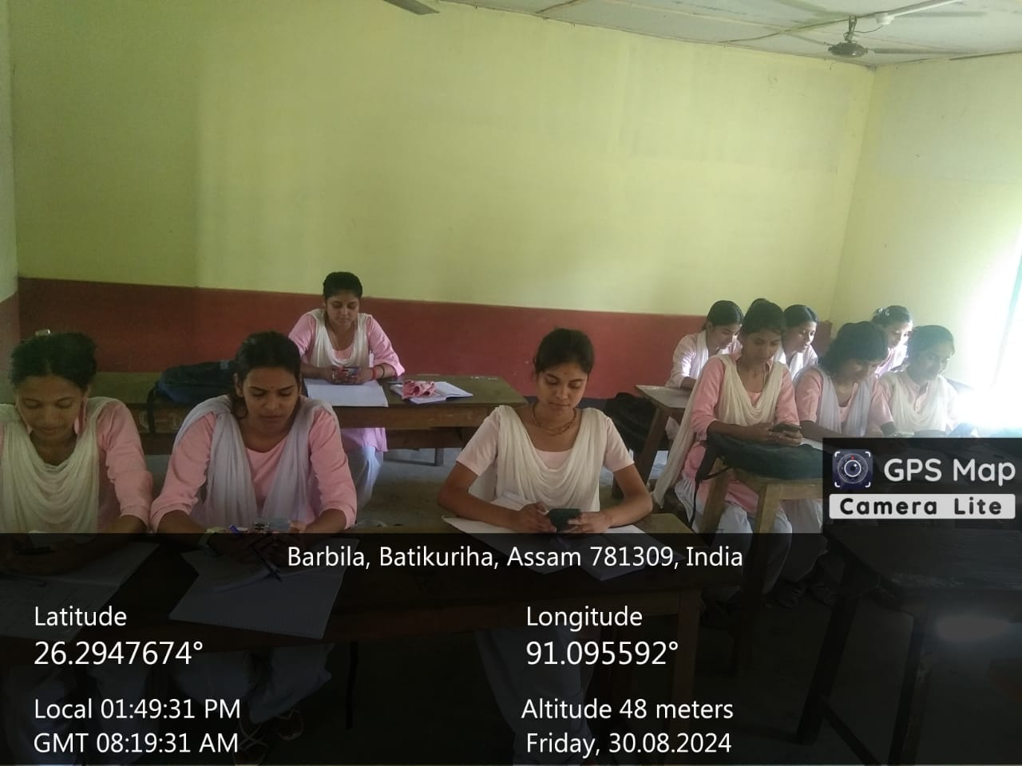
Student participant

Student participant

Certificates of qualified students:
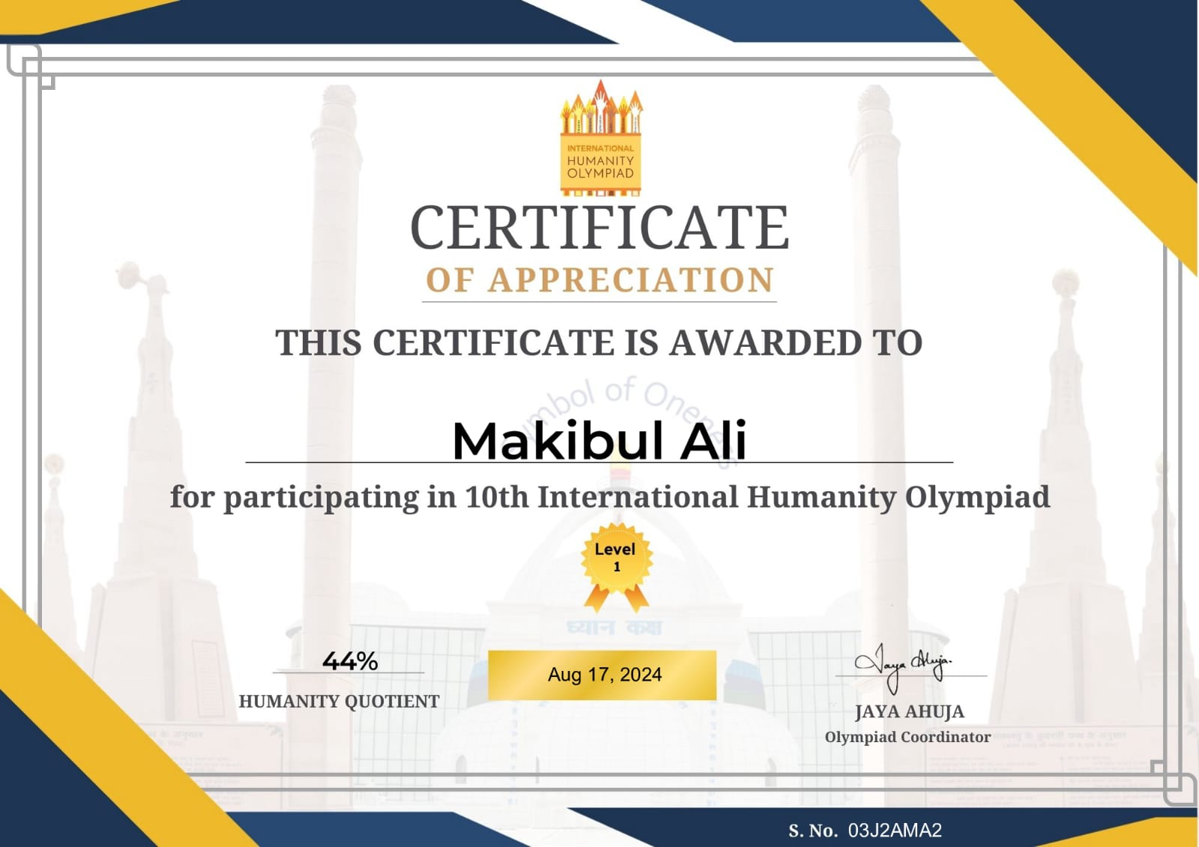
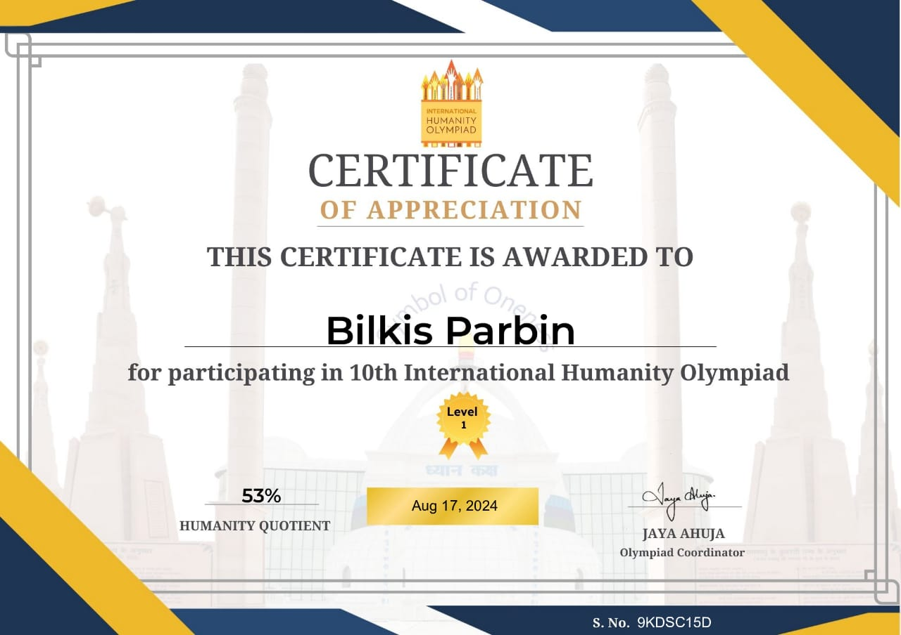

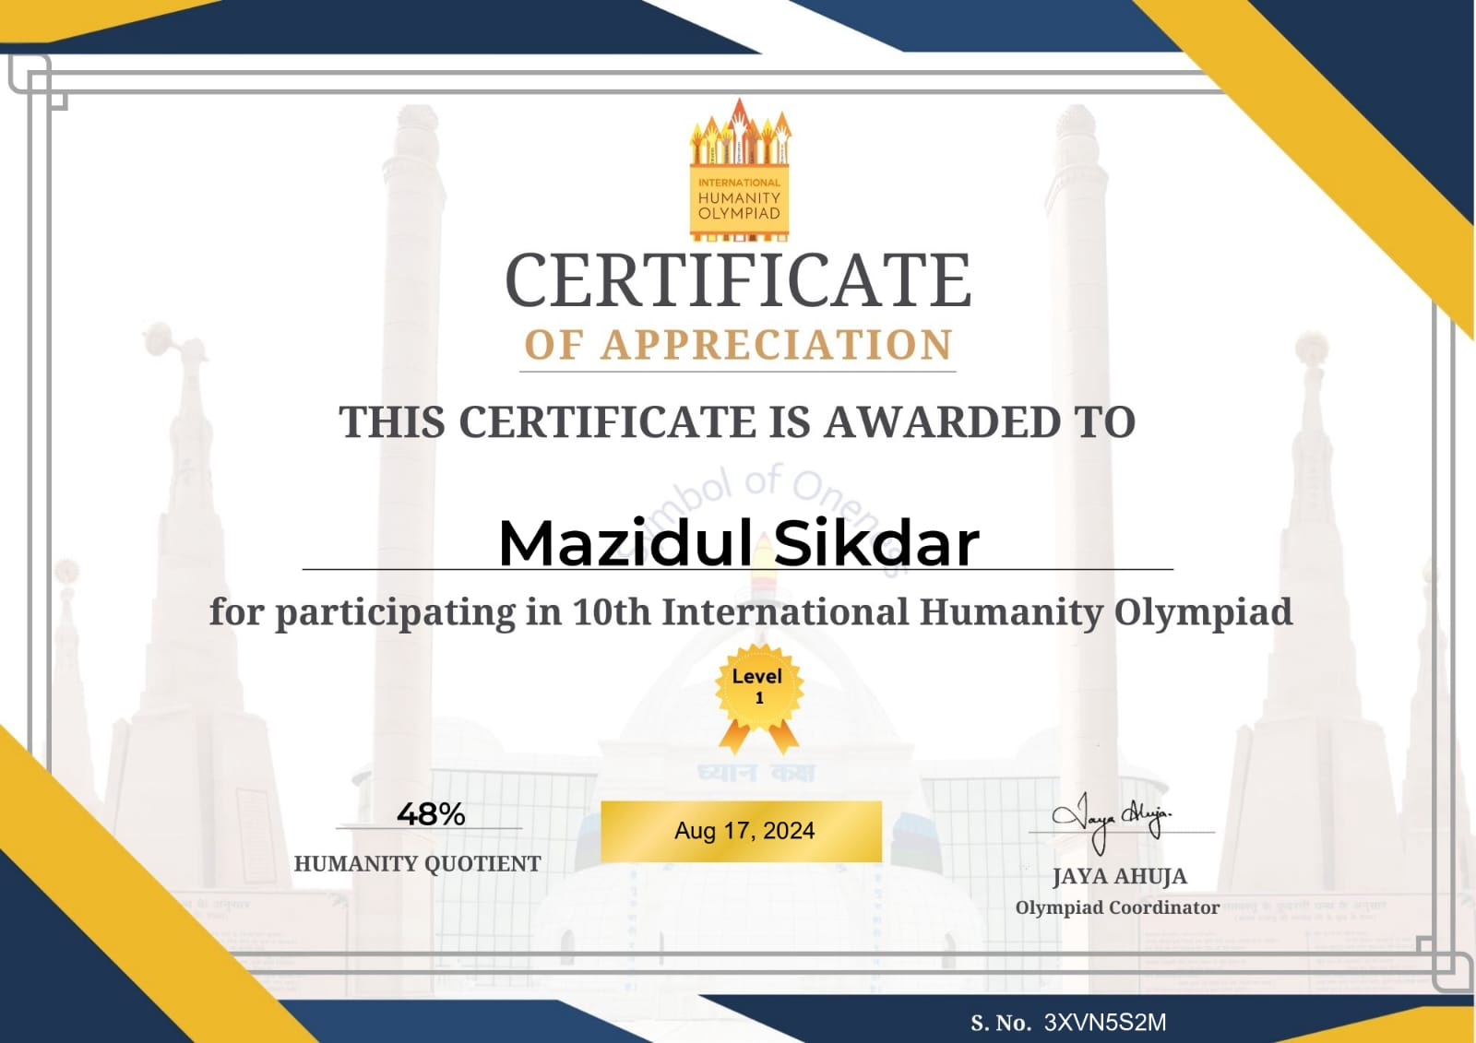
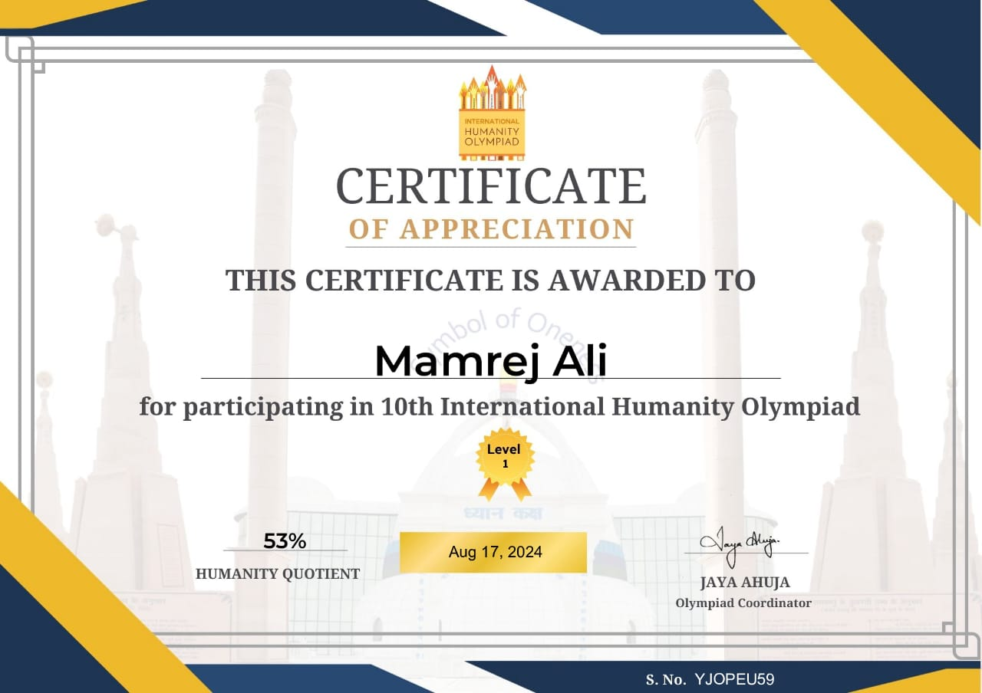

Dr. Manalisha Deka, HoD
Department of Zoology
BBK College, Nagaon, Barpeta

