BAOSI BANIKANTA KAKATI COLLEGE
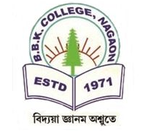
Dr. Manalisha Deka
HoD

Nagaon, Barpeta
Assam-781311 (INDIA)
Department of Zoology

Report on
World AIDS day at BBK College
Date: December 1, 2024
Location: BBK College, Nagaon, Barpeta
Venue: ZL, BBK College
Organized by: Red Ribbon Club in collaboration with IQAC

On December 1, 2024, BBK College observed World AIDS Day, a significant event dedicated to raising awareness about HIV/AIDS, combating stigma, and promoting efforts in prevention, treatment, and care. The program officially began at 11 A.M. with a formal opening ceremony. The Principal, BBK College delivered an insightful opening speech. In conjunction with the observance, an essay competition entitled "Challenges of HIV" was organized to engage students in thoughtful reflection on the issues surrounding HIV/AIDS. A total of 27 students participated in the competition, showcasing their knowledge and perspectives on the topic. Certificates of recognition were presented to the outstanding participants by the Principal, BBK College, in acknowledgment of their efforts and contributions to spreading awareness about this critical global issue. The event was a meaningful and impactful occasion, highlighting the importance of education, compassion, and action in the fight against HIV/AIDS.



Dr. Manalisha Deka, HoD
Department of Zoology
BBK College, Nagaon, Barpeta
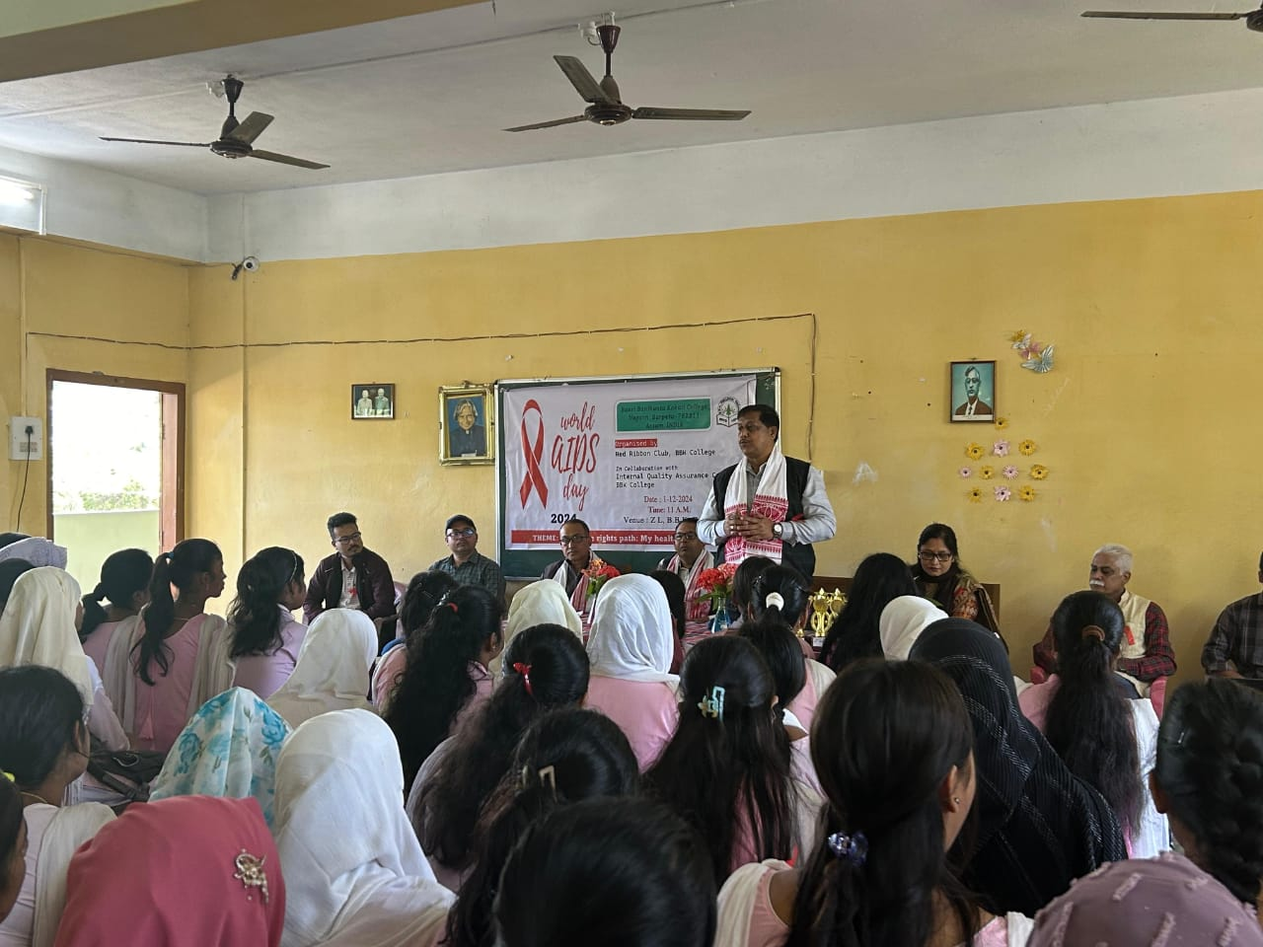
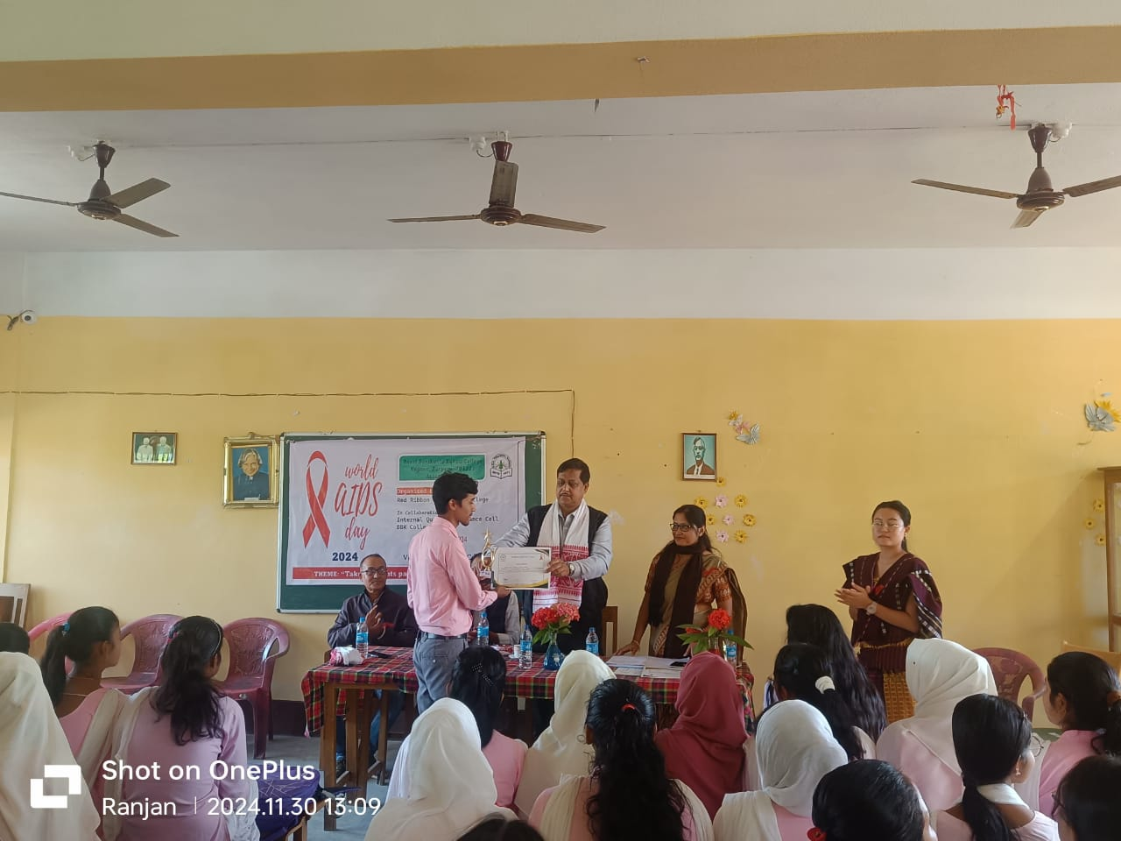

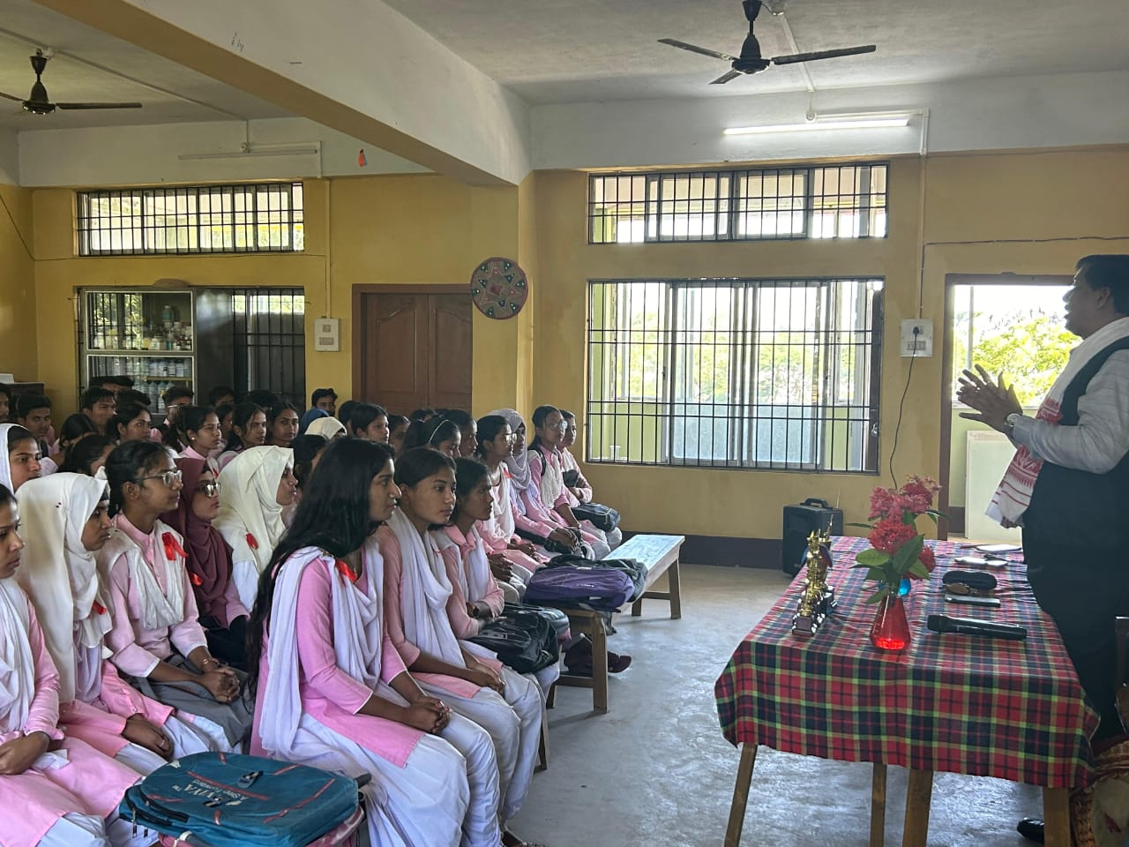
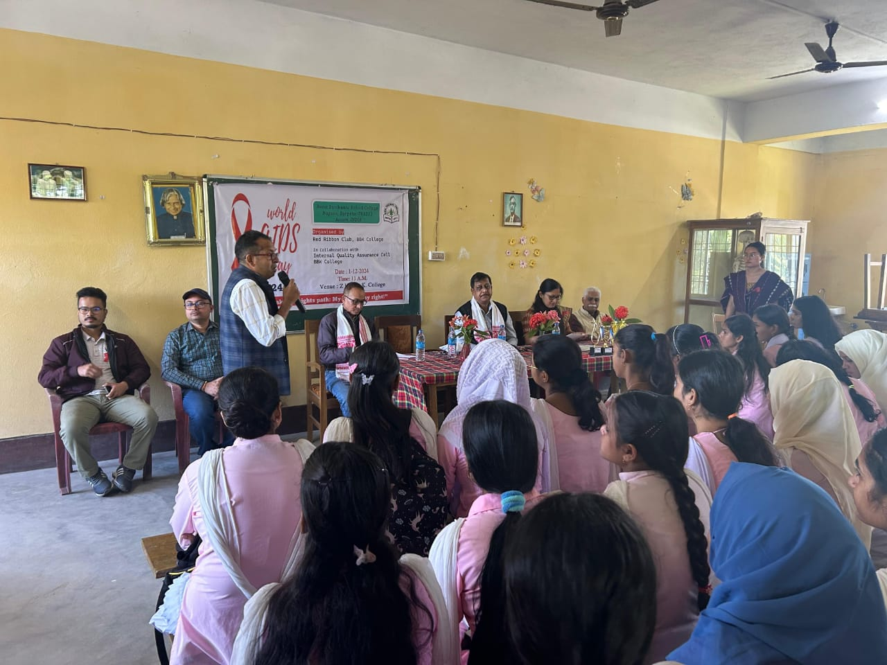

Dr. Manalisha Deka, HoD
Department of Zoology
BBK College, Nagaon, Barpeta

