BAOSI BANIKANTA KAKATI COLLEGE
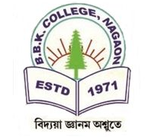
Nagaon, Barpeta
Dr. Manalisha Deka
HoD

Assam-781311 (INDIA)
Department of Zoology

Report on
Student Seminar Presentation, 2024
Date: March 7, 2024
Venue: New Hall, BBK College
BBK College, Nagaon, Barpeta
Department of Zoology

On March 7, 2024, a seminar on vertebrates was held as part of the student seminar series at BBK College, New Hall. The seminar began at 10:00 A.M. and featured an engaging PowerPoint presentation delivered by students, focusing on two distinct classes of vertebrates. The objective of the seminar was to explore the key characteristics, evolutionary traits, and ecological roles of these vertebrate groups, offering students the opportunity to examine both their similarities and differences. Throughout the presentation, students actively encouraged audience participation by inviting questions and comments, fostering an interactive and dynamic learning environment. The Q&A session, in particular, was marked by insightful discussions, with attendees exploring the species-specific impacts and other intriguing aspects of the vertebrate classes being discussed. The seminar provided a comprehensive exploration of the characteristics, evolutionary history, and ecological significance of the selected vertebrate groups. The students delivered the content in a well-structured, clear, and engaging manner, offering a deep dive into the fascinating world of vertebrates. Overall, the seminar proved to be a highly valuable educational experience. The students effectively showcased their research skills and presentation abilities, leaving the audience with a richer understanding of vertebrate biology.

Dr. Manalisha Deka, HoD
Department of Zoology
BBK College, Nagaon, Barpeta

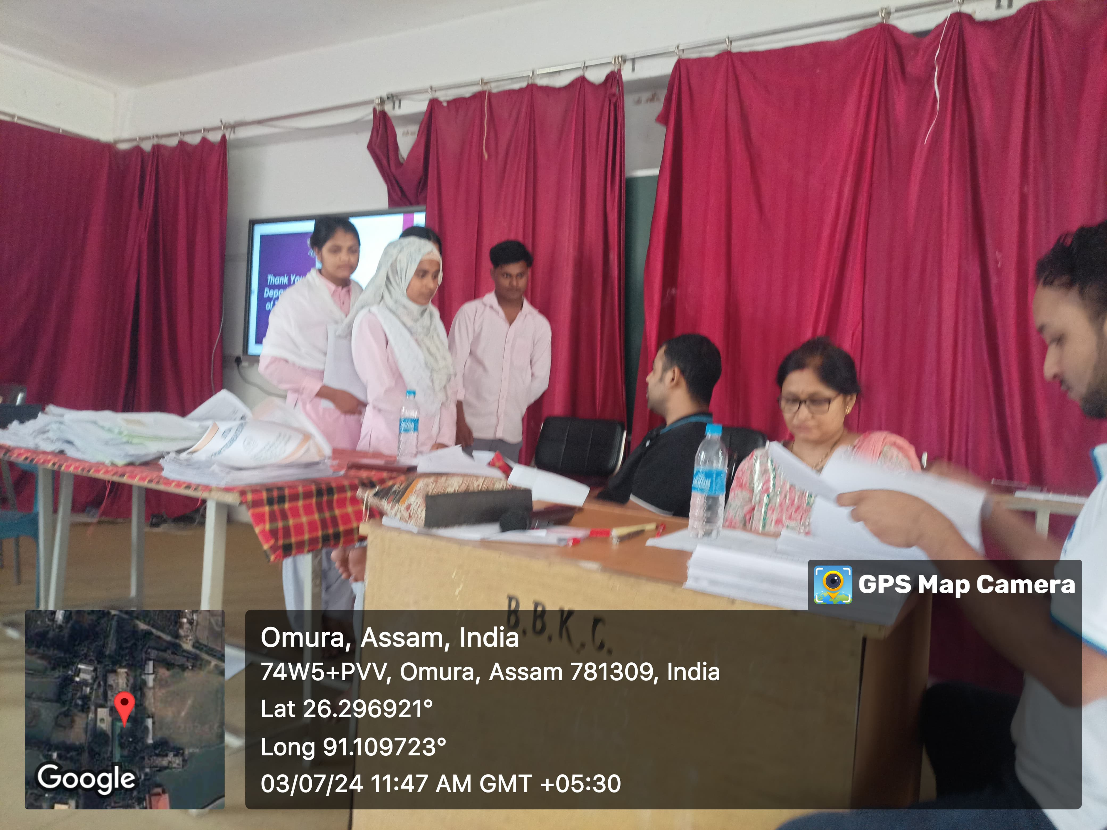
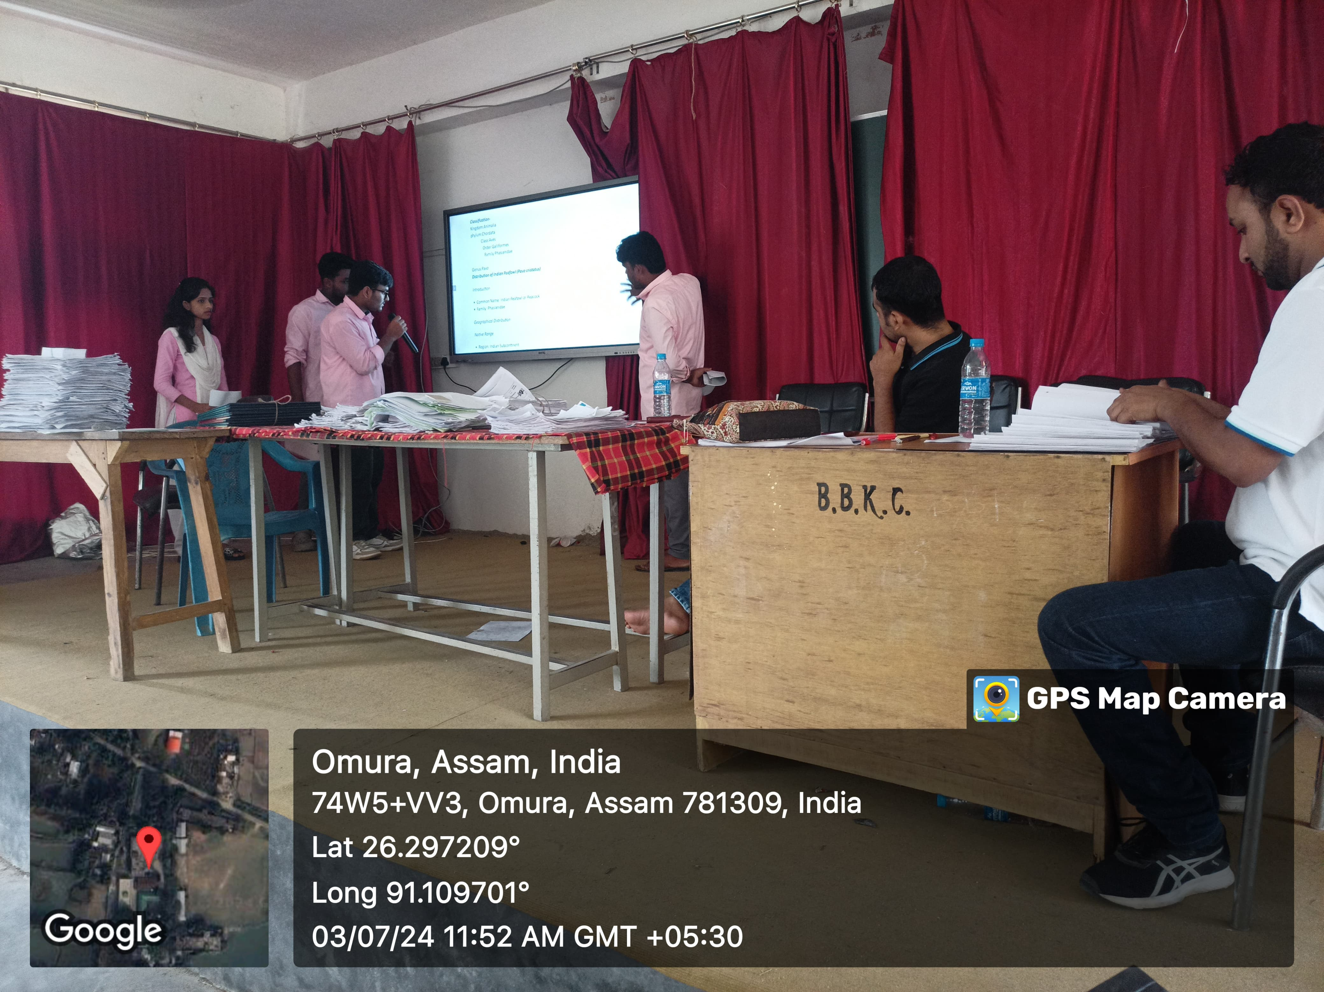

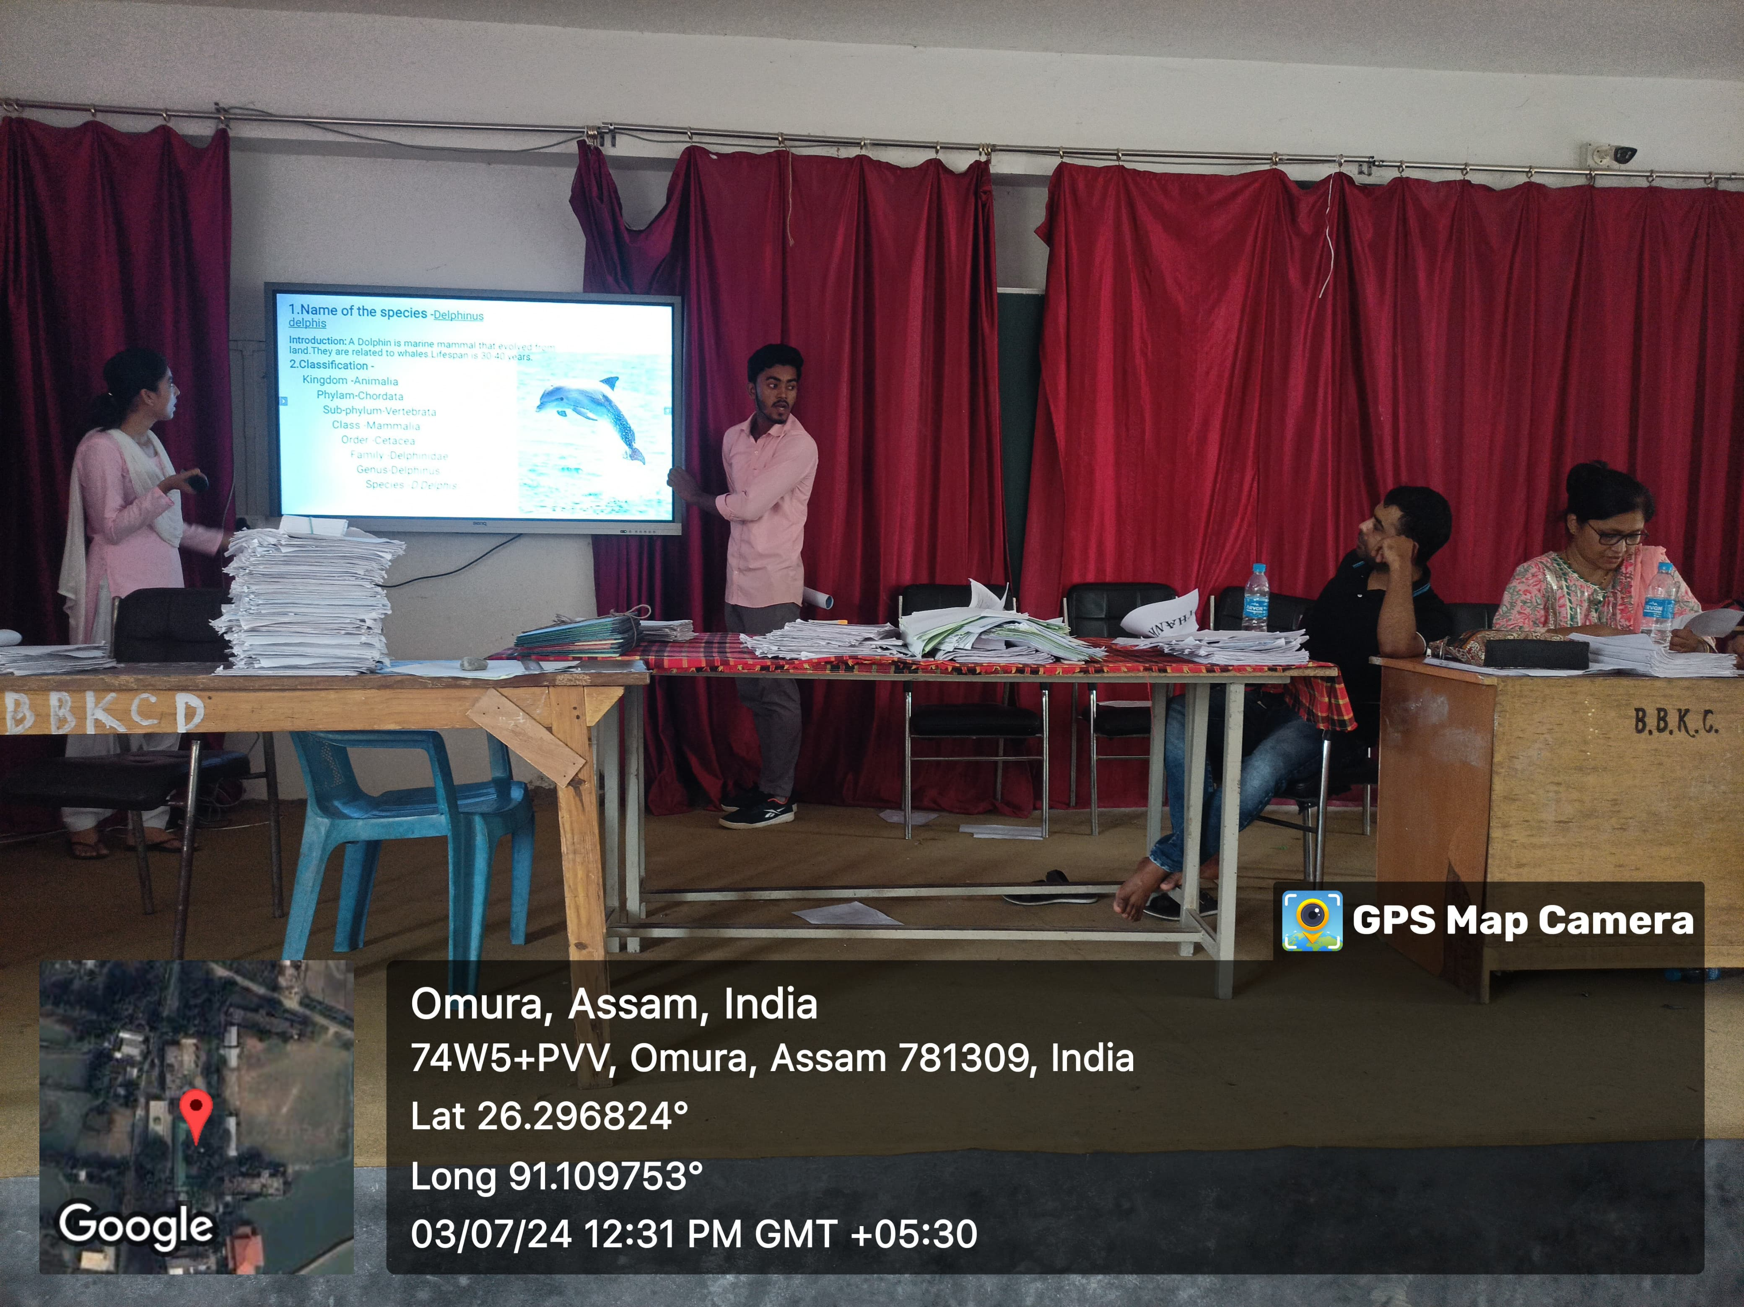
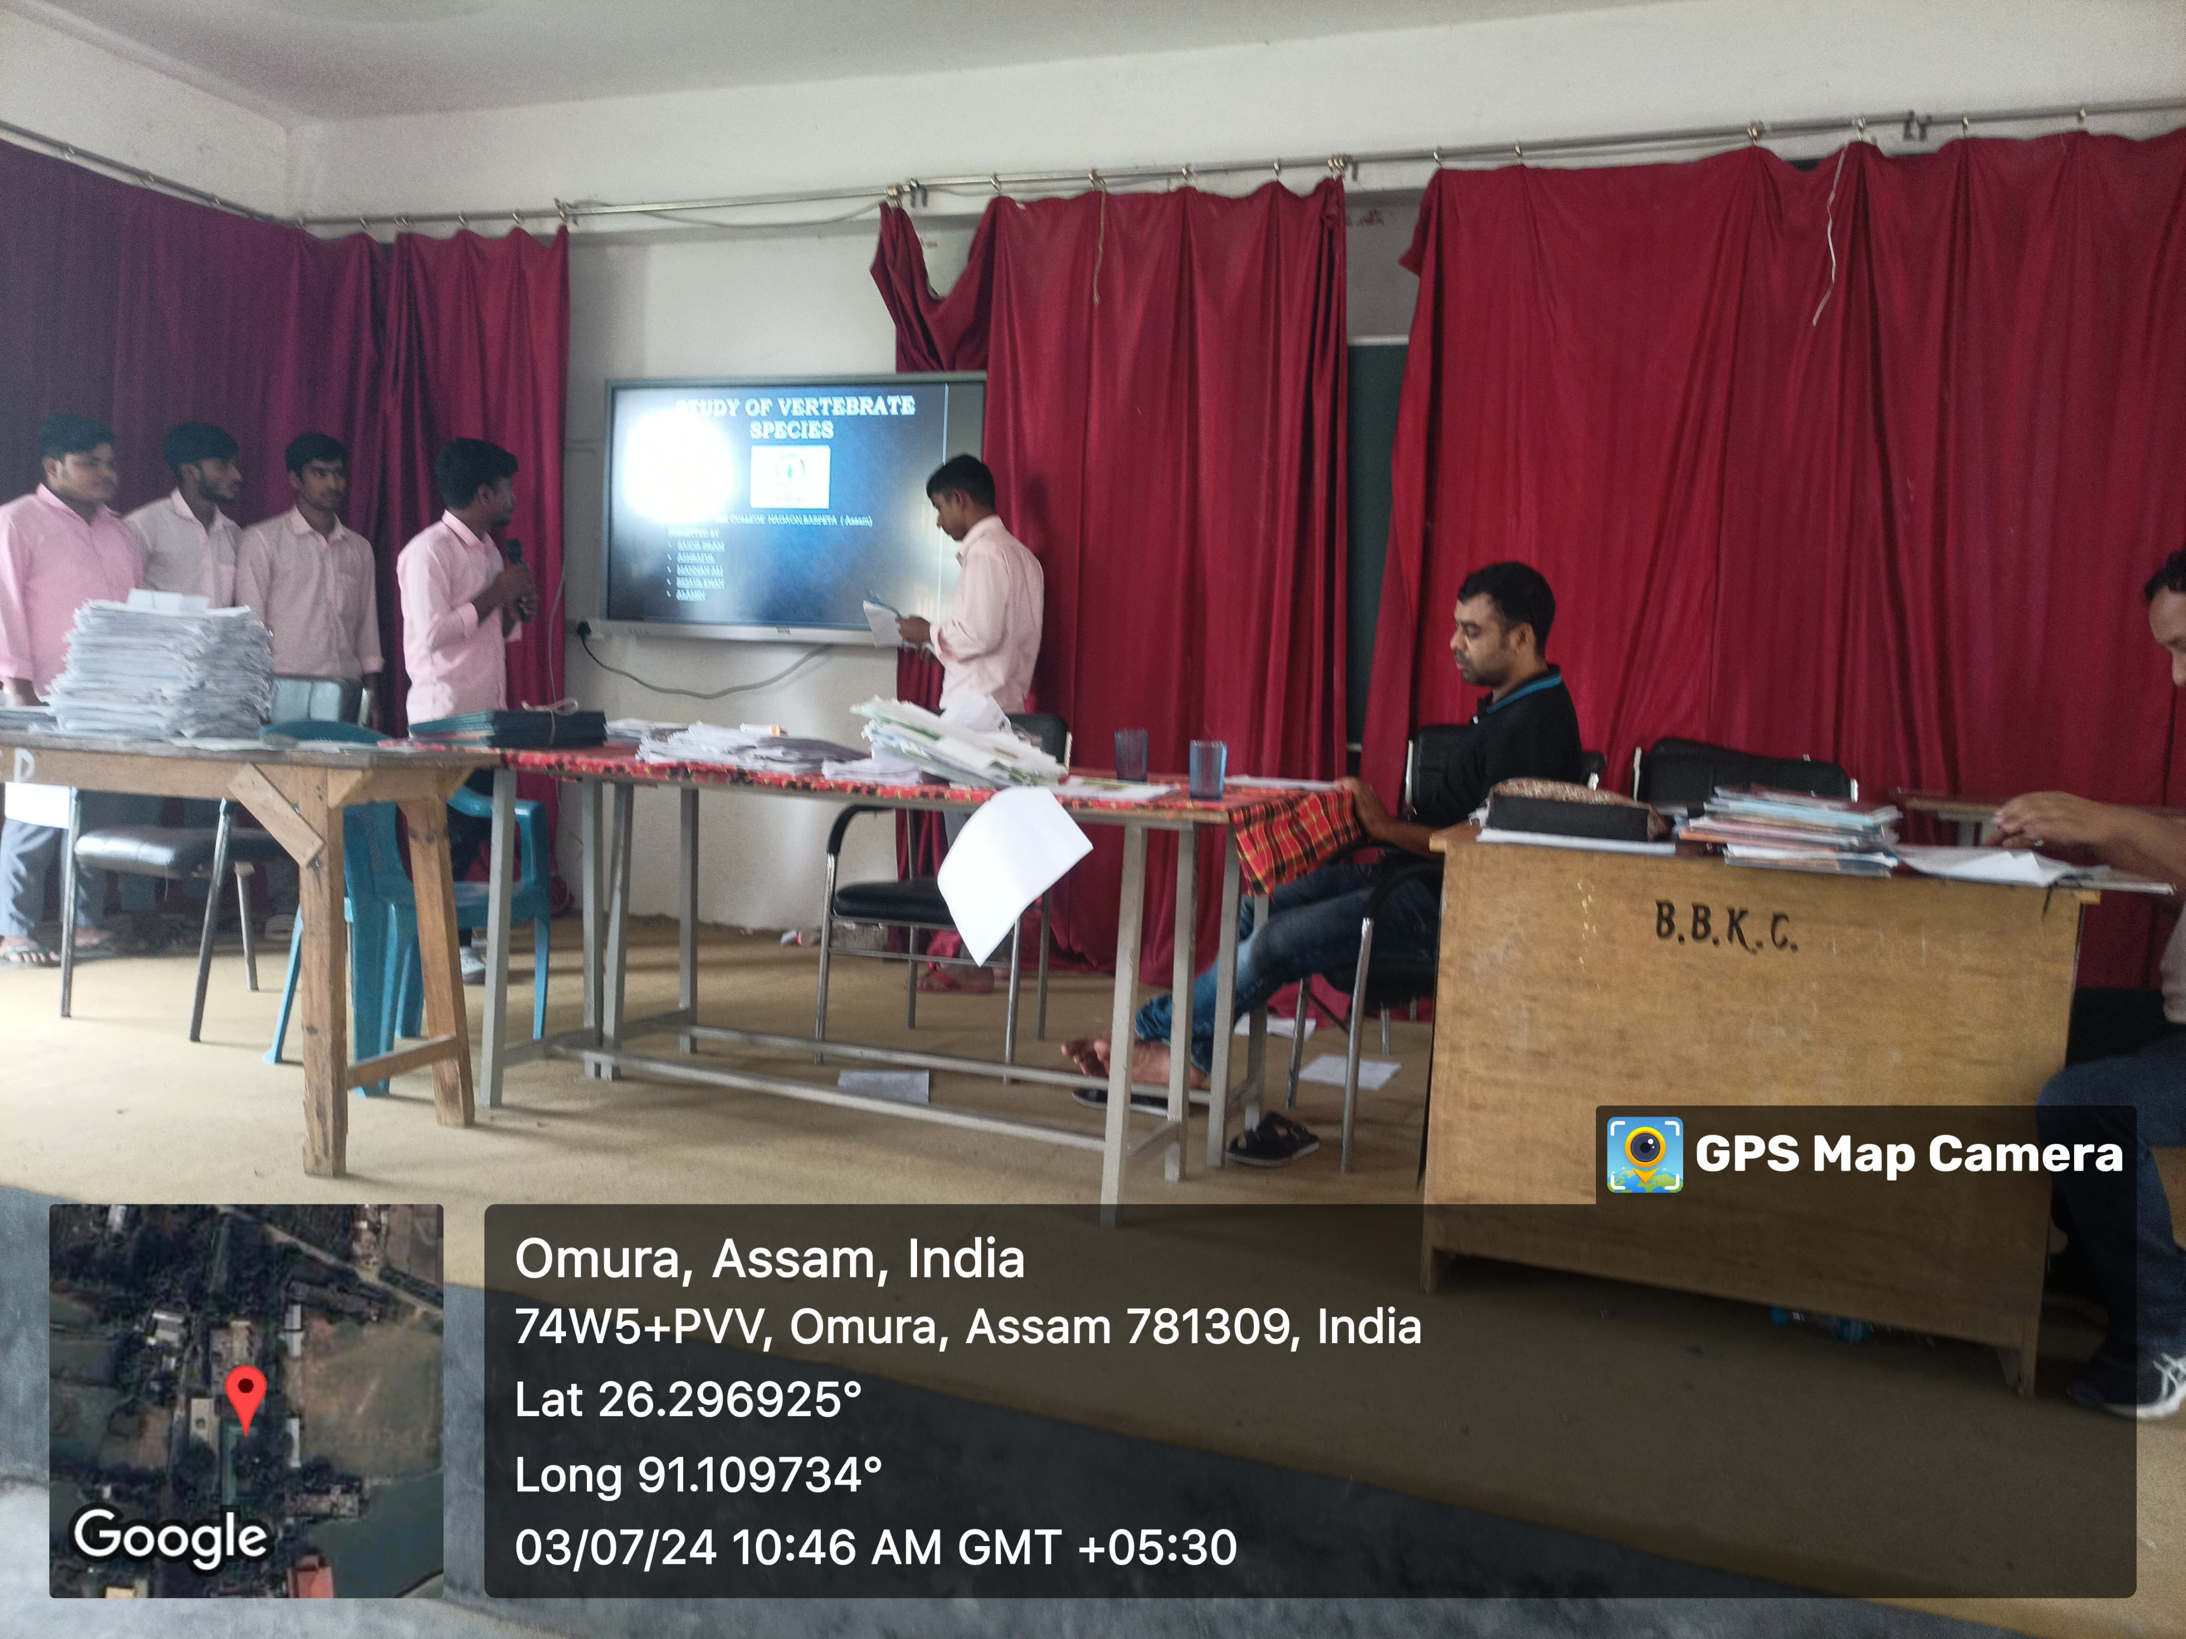

Dr. Manalisha Deka, HoD
Department of Zoology
BBK College, Nagaon, Barpeta

