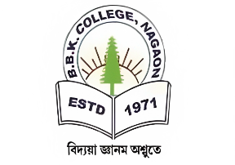
DEPARTMENT OF EDUCATION
BAOSI BANIKANTA KAKATI COLLEGE
Nagaon, Barpeta, Assam- 781311 Date: 23.06.2022
Report on-
Project Study, 2021-22
Semester-VI
Paper: Project (EDU-HC-6026)
The students of BA 6th semester of the Department of Education were assigned to do Project study on the different Topics chosen by the students on
The details of the program are given bellow:
Program | Program Code | Name of the course that include experiential learning through project work/field work/ internship | Course Code | Year of offering
BA EDUCATION | UG | HONOURS COURSE  (PROJECT WORK)0 | EDU-HC-6026 | 2021-2022

The students were trained to prepare their reports under the following Headlines:
- Title of the Project
- Introduction
- Importance of the study
- Objectives of the study
- Review of related literature
- Methods and Procedure
- Data Analysis
- Conclusion

A total number of 5 students participated in the project study as given bellow:
Roll Code:
SL No. | Name of the student | Roll Nos. | Name of the Schools visited | Date of Visit
1 | Barnali Malo Das | 0076 | B.R. Milan High School | 03.02.2022
2 | Mamoni Sarkar | 0109 | Nagaon Siksha Mandir | 03.02.2022
3 | Rakibul Islam | 0133 | Kahirabi High School | 03.02.2022
4 | Sikandar Ali | 0152 | Gelabil High School | 03.02.2022
5 | Smritirekha Deka | 0157 | Chenga Higher Secondary School | 03.02.2022

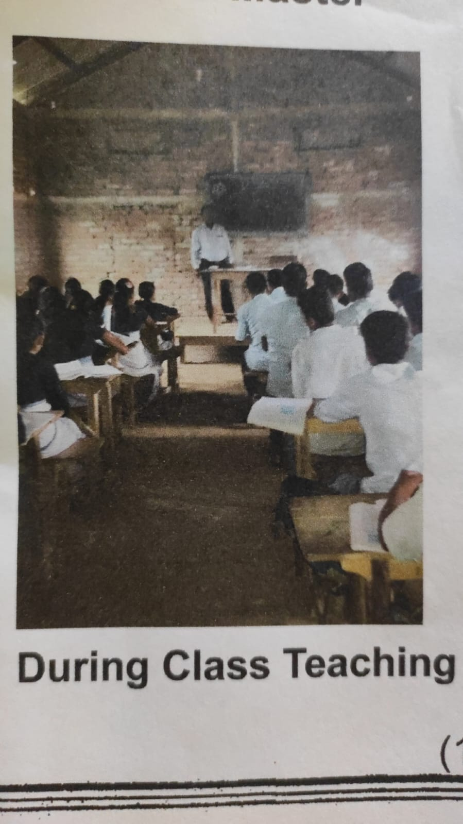
Photos enclosed::
Baosi Banikanta Kakati College, Nagaon, Barpeta, Assam- 781311
www
s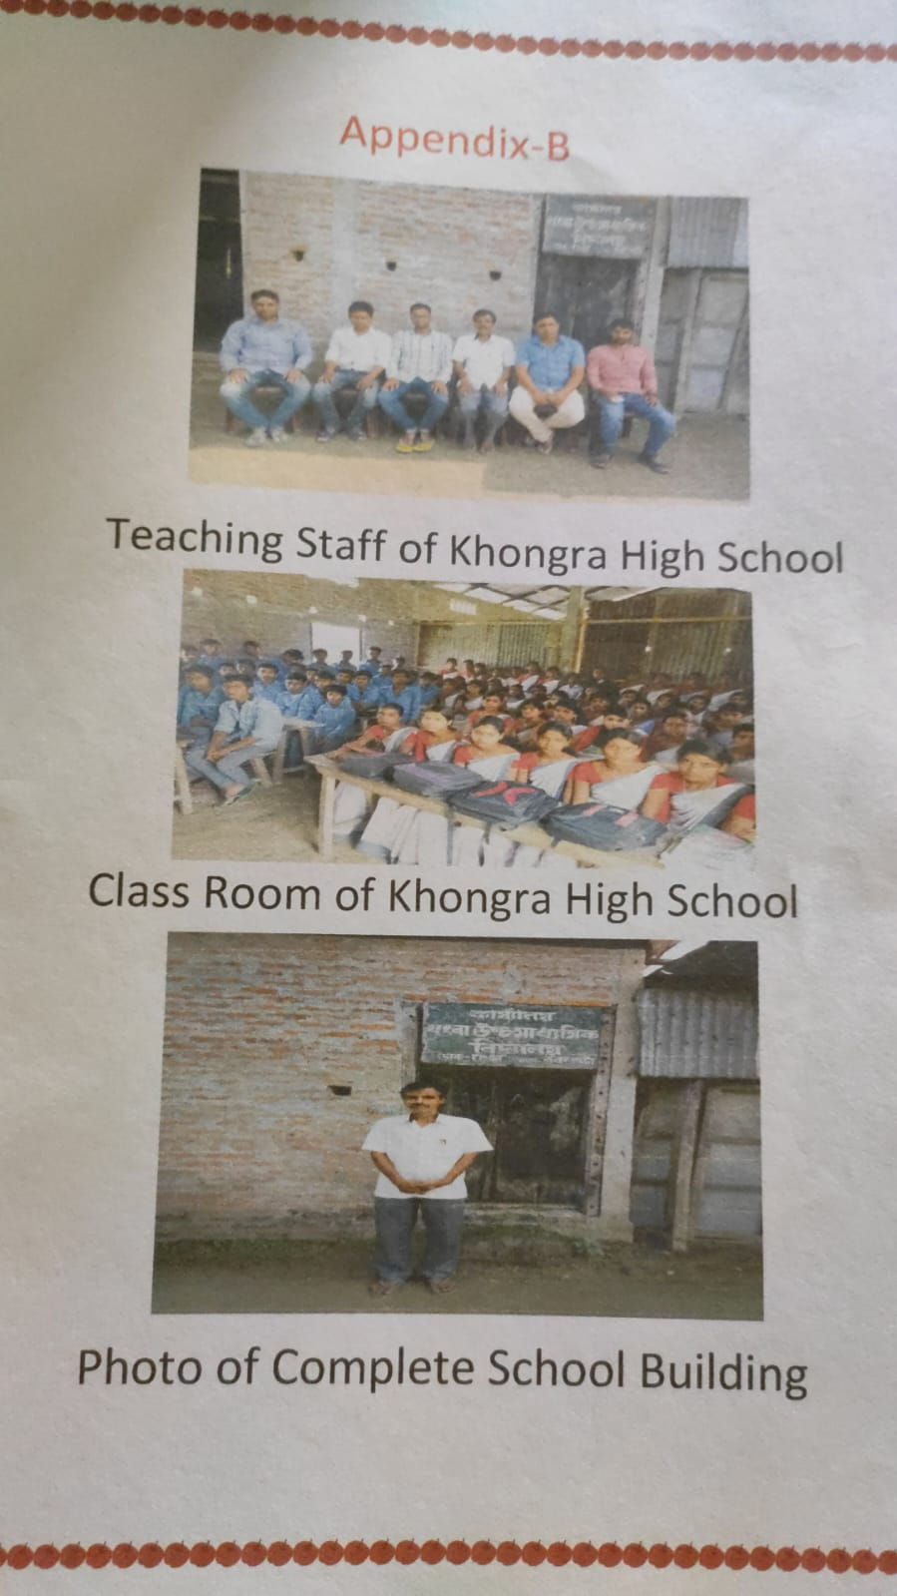
 Signature of HOD
Baosi Banikanta Kakati College, Nagaon, Barpeta, Assam- 781311
www
Dept. Of Education

