Field Report on Fairs and Festivals of Bodo Community of Damraboa Village, Nagaon, Barpeta District

Introduction of the Topic
Festivals and Fairs constitute an important aspect of cultural life of a community. Since ancient times, festivals have been associated with mankind as an important feature of group of life. The society of the Bodos is agricultural one. From the study on the festivals of the Bodo Community of Damraboa Village, conclusion may be made that all religious and non-religious festivals are more or less connected with agriculture.
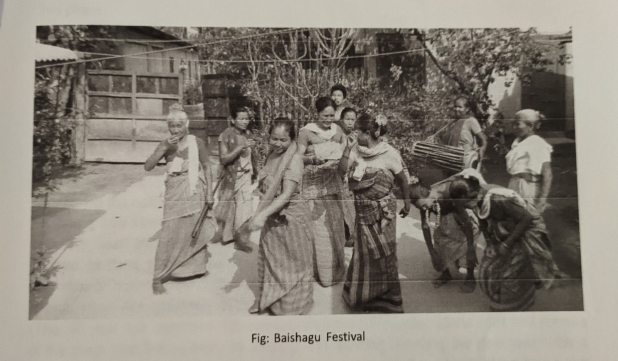
The field work was done on October 2020.

Name of the Supervisor
- Dr. Mami Ojah
Name of the students participated in this field work are follows:
- Aniruddha Das
- Manabjyoti Nath
- Nasrina Ahmed
- Rimi Choudhary
- Sariful Islam

